ISTANBUL TEKNIK UNIVERSITY
Computer Engineering Department

GENOPE

Sinan Kaplan
Hasan Toprakkaya
Erhan Deniz

May 2005 Turkey
Description of Problem

In Today worlds, communication is the one of the most requirements of the humankind. According to this requirement, lots of communication devices developed such as telephone, messaging services, video services, and conference services. Because of the improvements in the Internet technology, the substructure of the communication is applied over the Internet. So, the cost of the communication is decreasing. On the other hand, different services on the different devices try to achieve the communication requirements of the humankind.
Genope tries to join communication platforms and tries to achieve all the communication requirements without devices differentiations.. Genope is the collection of all communication services in one place.

Similar Projects

- Chatin
This project is developed by Mobinex , its features are
- Communicate mobile phones over GPRS.
-Written Symbian OS for SmartPhones
- Skype
Its features are;
- Communicates PC and PALM devices over Internet
- Written for Win32 and Win CE
- IM+
This project is developed by SHAPE services
Its features are;
- Communicates PCs and SmartPhones
- Written for Win32 and Symbian OS for SmartPhones

The Goal of the Project

The goal of the project is to design a platform that provides distributed systems to communicate over Internet.

This system will give the computer users the opportunity to communicate independent of the GSM operators.

Communication may be considered in two ways:

- Instant communication (chat, talk)
- Non-instant communication (SMS, MMS, voice messages)

In this system, external interface of the clients will be just the same. There will be no difference between the users of mobile phones, computers or PDAs.

The users registered on the system will be given a unique ID and password. The user may log in to the system from any machine using this information. After logging in users may check for his new messages or send messages. They can also talk or chat with the online users. The client will transfer the voice of the user to the other side as packets as soon as the connection is set.

The user will be able to form his own contact list, compose groups, view whether a user is online or not and call a chosen user.

The user may also send or receive SMS/MMS, obtain the cell information and the condition of the sent messages; delivered or pending.

Project Scope

In the development time of this project, the team worked together with the project adviser using the ordered work schedule. The communication of the distributed systems is the core of the project. In the beginning of the project, we developed the simple version of this core. After that, we expanded the core for the requirements. We developed the modules around the core to create a project that can be use in the real world.

Project Benefits

We believe that communication between people is one of the most important issues in today’s world. So this project’s aim is to make the communication between people cheaper, easier and widespread. Project removes the client differences and connects almost all clients with different technologies. A PC user can communicate with a mobile phone user. They can send messages, files and voice records to each others. This Project enables people’s communication any time and any where. A user can add other users to his/her contact list and make friendship with them. Contact list and messages are kept in server so a user can reach his/her account with any known device that has an internet access.

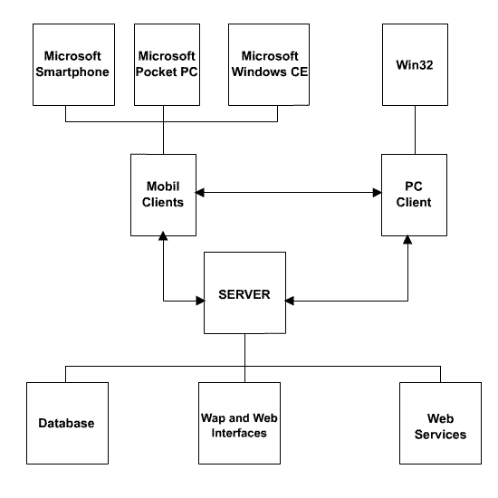
Server Structer of Genope

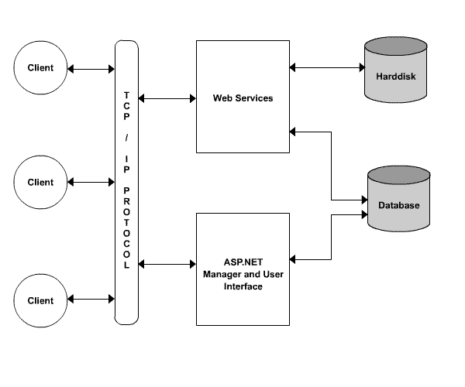
Web Service Structer of Genope

We can group the server side of the Genope Project in 3 main categories

- Database
- Web services
- Web Interfaces

Clients are basicly of two types:

- clients directly connected to the Internet
- clients connected to the Internet over GPRS

Expected basic functions of clients are as follows:
- Usage of web services
- Message facilities
- User records
- Voice record
- Socket connection to an another client
- User interface
- File management

RESULTS AND SUGGESTIONS
An application is developed that it is reusable, extendable and have different platform support. This application is developed using .NET platform efficiently with a layered architecture and distributed programming techniques. The features of the architecture enable addition of new services to the system and make the project more extendable. While developing this project, we had a serious software development experience in .NET development environment along with different popular technologies. We had a considerable knowledge on mobile devices and mobile technologies.

More additions can be made to the system. Although the system uses session manager for security, data traveled between clients and server can be encoded with using appropriate encryption algorithm. A compression algorithm also can be used to reduce the size of the data transmitted for transmission speed and efficiency. The AMR codec can be used for loosely compression of voice. For other data, well known LZW algorithm can be used. Various services also can be added to the system easly.

