GE 400 ENGINEERING DESIGN PROJECT

SMART GREENHOUSE

Submitted by:
Mustafa Kara (EE)
A. Osman Sevim (EE)
Serkan Oral (EE)
K. Tolgahan Narin (EE)

Project Supervisor: Prof. Feza Kerestecioğlu

Faculty of Engineering
Kadir Has University
Spring 2005

ACKNOWLEDGEMENTS

We would like to thanks Festo San Tic A.Ş for their financial and technical helps in the preparation of this project.
Especially, we would like to express our gratitude Prof. Feza Kerestecioğlu for precious technical information that illuminate us on critical stages, and close guidance on all aspects of the project. .
We want to thanks Yard.Doç.Dr. Erdal Üzen, Istanbul University-Faculty of Science-Botanics, for guidance about agricultural issues.
We proffer our grateful to Kadir Has University administration for project contribution, wide laboratory accessories.
Ahmet Kıymaz, who is the owner of Akçelik San.Tic. Ltd. Şti, has built us metal framework for our greenhouse and assists us for mounting solid equipments.

ABSTRACT

Smart greenhouse is a PLC based greenhouse automation that support all type of equipment used in greenhouse and have the ability of evaluating analogue, humidity, temperature etc. and digital, rain sensor, light sensor, position check switch etc. inputs.

PLC is programmed to control all environmental processes and to monitor all errors occur on the systems operations. Moreover some conditions are measured by PLC or the circuit that we implement.

The system is implemented by pneumatic actuator, so system is clear, safe, and easy to implement. By taking feedback signals from the position, irrigation check, etc. sensors the PLC decide if the action is realized accurately. If there is something wrong, operator/user is instantly informed by the operator panel, alarm light and buzzer.

In addition to pneumatic components, mechanic side consist; shading, lighting, fogging, pesticide pulverizing, dripping system.

And there are day time applications and crop growing model with installing condition parameters of the related crop. This is a standalone control system. As result, general spending (labor force, pesticide, and water) for resources of greenhouse is decreased.

TABLE OF CONTENTS

ACKNOWLEDGEMENTS ……………………………………………………………… | 2
ABSTRACT ……………………………………………………………………………… | 3
1 INTRODUCTION ……………………………………………………………………… | 6
1.1 Aim…………………………………………………….……………………………. | 6
1.2 Motivation…………………………………………………………………………... | 6
1.3 Customer Expectations……………………………………………………………… | 8
1.4 Current Technology………………………………………………………………… | 9
2 THE BUILDING ……………………………………………………………………….. | 10
2.1 Types of Greenhouse Structures………………………………………………......... | 10
2.1.1 Attached Greenhouses……………………………………………………… | 11
2.1.2 Freestanding Structures……………………………………………………... | 12
2.2 Structural Materials ……………………………………………………………........ | 13
2.2.1 Frames………………………………………………………………………. | 13
2.2.2 Coverings …………………………………………....................................... | 14
2.3 Foundations and Floor …………………………………………………………….... | 16
2.4 Location …………………………………………………………………………….. | 16
2.4 The Building of “Smart Greenhouse ……………………………………………….. | 17
3 CONTROL PROCESS…………………………………..……..……..……..………….. | 20
3.1 Climate ………………………………………………………...……..……..……… | 21
3.1.1 Heating & Cooling …………………………………. ..……..… ..……..…... | 22
3.1.2 Ventilation……………………………………….....……..……..……........ | 23
3.1.3 Humidity & Mist Systems………………………….................……..…….. | 25
3.2 Irrigations………………………………………………………..……..……..…….. | 26
3.3 Lighting………………………………………………………....……..…..……....... | 27
3.4 Shading……………………………………………………..……..……..……..…… | 27
3.5 Sensors…………………………………………………………..……..……..…….. | 28
3.5.1 Limit Switch………………………………………...……..……..………… | 30
3.5.2 Rain Sensor…………………………………………....……..……..………. | 31
3.5.3 Wind Sensor……………………………………….......……..……..………. | 31
3.5.4 Temperature Sensor…………………………………....……..……..…….. | 31
3.5.5 Alarm Buzzer…………………………………………..……..……..…….. | 33
3.5.6 Light Sensor…………………………………………....……..……..……… | 33
3.5.7 Air Humidity Sensor…………………………………...……..……..……… | 33
4 PROCESS INTEGRATION……………..……………………………………………... | 34
4.1 Software Integration…………………………………………..…………… ……… | 34
4.2 Receipt Based Automation………………………………………………………… | 34
5 CONCLUSIONS…………………………………………...................………………… | 36
APPENDIX A International Ingress Protection Codes…………………....……………… | 37
APPENDIX B Electronic Schematics ……………………..……………......……………. | 40
APPENDIX C Troubleshooting Guide……………………………….…...……………… | 43
REFERENCES……………………………………………………….…………………… | 46
1 INTRODUCTION

  - Aim

The main purpose of implementing greenhouse automation is to provide required temperature, air humidity, soil moisture, light and watering levels independent from outer environmental conditions. By this way maximum productivity from unit area will be obtained so that farm will have been handled in most efficient way.
Controller type and its peripherals must satisfy required customer expectations. Traditional greenhouse owners look forward to user friendly interface, scalable input and output ports that are compatible with any type of greenhouse equipments, faultless control system from such automation system. In addition to customer expectation, suitable software algorithm is to developed to save different crop conditions in single microprocessor.
For related control system we should also clarify right sensors to measure environmental conditions. These conditions can be either outdoor (weather, rain, outer temperature) and indoor (the positions of moving parts, humidity, inner temperature, soil moisture, light)
Greenhousing is not consists only electrical and mechanical actuators, the building is also one of the important section to provide overall efficiency. Greenhouses can provide excellent controlled environment for plant production, so they are design to supply efficiently. The greenhouse should supply uniform lighting, heating, humidity, shading and water to all plants. The greenhouse automation system is to minimize the consumption of pesticide, fertilizer, water, energy and employment.

  - Motivation

Starting point of greenhouse automation is to increase the productivity of agriculture and improve the quality of harvest. Providing optimum temperature, humidity (both soil & air), light and watering levels, it is possible to obtain maximum productivity from unit area, so that farm will have been handled in most efficient way.[1] In many developed countries it is impossible to survive without automation, due to high labor costs, liability costs for employees (heavy work) and environmental costs (water recycling, etc.). The greenhouse automation system minimizes the consumption of pesticide, fertilizer, water, energy (electricity, fuel, etc.) and employment. According to Argus Control[] in U.S.A; such automation systems present following advantages to the producer;
- %45 decrease in use of pesticides
- %65 less employment
- %65 decrease in general spending
- %65 more efficient method (modern & faultless control system)
- %65 improvement on conditions (HVAC; heating, ventilation and air condition )

Moreover, a Disposal Report of Producers in California [] says that greenhouse automation systems provide following returns;
- %20 less use of electricity,
- %30 less fuel consumption,
- %30-%75 less water consumption

Therefore, our automation system is expected to create surplus value for both producers and national economy. Additionally, inside the greenhouse, crops will be protected against damages caused by rain, wind or other weather conditions. On the other hand, by recording the actions and HVAC parameters, the system will support the criterions for the organic agriculture-evidence for the naturalness of the crop. Moreover, we will ensure the complete customer satisfaction by preparing user manual and trouble-shooting guide. System maintains the reference values taken from built in crop growing condition parameter.

  - Customer Expectations

The type of plant that will be grown in a greenhouse varies according to location of the farm, and annual market demand. Therefore a perfect greenhouse should support providing the necessary conditions for any plant, from mushroom to tropical plants, from flowers to industrial vegetables. There are many types of greenhouse equipment, and all these equipment need to be controlled with single controller. Thus, controller unit should include necessary connection ports that are compatible for any equipment that has a possibility of using in greenhouse.
Most of farmers do not want to learn new methods about horticulture; they already know how to raise their plants, and they have enough experience. They don’t want to accept new technology, say “I am a grower, not a manager” []. Therefore, the user interface must be very simplified and easy to use. Professional growers want some manual operations in addition to automatic manipulations.
Moreover, greenhouse production offers a wide variety of plant choices, including those that may be grown year round and those that can be transplanted outside. Cold tolerant vegetables such as lettuce, spinach, scallions, parsnips, beets, chard, radishes, and turnips are easily grown in a greenhouse throughout the off seasons[]. Crops that likes warm weather such as melons, peppers, eggplants, and tomatoes can be started early in the greenhouse for later transplanting outside or can be grown inside the greenhouse all the way to harvest. Such crops will not yield as well in winter but it is possible to get tomatoes in winter with added light and heat. For winter growth in the greenhouse look for varieties of plants grown in the South which are varieties adapted to short-day culture. Whether you plant cold tolerant or heat loving plants, timing is key issue in greenhouse growing. Once you understand your greenhouse climate and light conditions you will be able to schedule plantings to maximize growth and harvest. Other possibilities for greenhouse growing include herbs, specialty or delicate plants such as orchids, some types of mushrooms, bedding plants, potted flowers and, cut flowers. Therefore, the systems equipments, select suitable sensors, heaters, coolers, ventilators, should support, all possible environmental conditions. Range of the reference values should cover all probable entrances. Also, software should support day time applications.
Faultlessness of the system is the important factor, and that result significant consequence on the user’s satisfaction. Therefore, such automation system should comprise error check algorithms and alarm indicators. Only income from the greenhouse is their harvest that gets annually or twice a year, so you should protect the crops from any accidental actions that results from any broken valve, blowing pipe, or malfunction on sensors.
The cost of the automation system is one of the important criteria that changes greenhouse owner’s behavior. Without automation greenhouse agriculture provides to owner certain amount of income, by adding automation to system total revenue must rise anyway. Otherwise, implementing a processor based control system seems illogical. While price increases, demand decreases. Therefore, price of such system must be lowered in any case. In addition to controller, other expenses such as calibration need, service demand, upgrade expenses, type converting expenses etc.
Greenhouse is not pure construction; it must include functional algorithms and measurement techniques. For long term users, installing a time based multi variables will create added value in green housing. That will protect crop from the wrong actions of the amateur users, so that results better conclusions.

1.4 Review of Current Technology

There are many companies in this market. All these firms support similar automation solution. There are nearly 3000 companies in U.S. All these companies use same major solution for greenhouse systems. Ventilation, fogging, irrigation, heating, cooling, shading, lighting etc. functions are stained with different controller units. So that will increase the total cost of ownership for full automated greenhouse system. However, our system offers complete and all in one solution for customer. From hobby user to industrial producer can easily implement such system in their farm.
On the other hand, system’s sophisticated software algorithm provide the efficient use of the resources, such as water, electricity, labor force (by automation of equipment usage), pesticide (by using special sprayers), and effective use of sun light.
Smart greenhouse automation support recording of crop growing parameters such as tomatoes require temperature about 25°C, %40 humidity, min 9 hours daily sun light, min 3°C, and maximum 39°C environmental condition. Moreover you can install various plant profiles to the same processor unit. Also you can select either profile from the operator panel at any time.
Our greenhouse system includes many feedback sensors and intelligent measurement techniques. By this way system provide uninterrupted control mechanism.
If there is any error on the actuators, motors or pumps, system automatically determine where the error occurs and operator panels inform the user about the malfunction. Than alarm buzzer and light alert the user about problem. By using troubleshooting guide (appendix3)

2 THE BUILDING

Generally greenhouses are attached to a building (house, shed, barn) or are freestanding. Most commercial greenhouses are freestanding. Whichever type you choose, the best placement is such that light is captured from all directions. For an attached greenhouse, the south side of a building will be the sunniest all year. The north side is not recommended and the size is to be proportional to 80/20, called 80/20 rule. Wind is another factor to consider in deciding where to locate a greenhouse, especially one that is freestanding. Considering different environmental conditions, there are some types of greenhouse structures. First we talk about types of greenhouses structures, structural materials, location foundations and floor, regarding the report of David S. Ross, West Virginia University[5] , and then we inform you about our project building.

2.1 Types of Greenhouse Structures

A home greenhouse can be attached to a house or garage, or it can be a freestanding structure. The chosen site and personal preference can dictate the choices to be considered. An attached greenhouse can be a half greenhouse, a full-size structure, or an extended window structure. There are advantages and disadvantages to each type.

2.1.1 Attached Greenhouses

Lean-to
A lean-to greenhouse is a half greenhouse, split along the peak of the roof, or ridge line (Figure 2.1), Lean-tos are useful where space is limited to a width of approximately seven
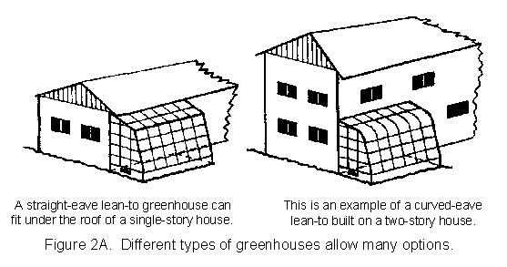
Figure2. 1 Greenhouse Types

to twelve feet, and they are the least expensive structures. The ridge of the lean-to is attached to a building using one side and an existing doorway, if available. Lean-tos are close to available electricity, water and heat. The disadvantages include some limitations on space, sunlight, ventilation, and temperature control. The height of the supporting wall limits the potential size of the lean-to. The wider the lean-to, the higher the supporting wall must be. Temperature control is more difficult because the wall that the greenhouse is built on may collect the sun's heat while the translucent cover of the greenhouse may lose heat rapidly. The lean-to should face the best direction for adequate sun exposure. Finally, consider the location of windows and doors on the supporting structure and remember that snow, ice, or heavy rain might slide off the roof or the house onto the structure.

Even-span
An even-span is a full-size structure that has one gable end attached to another building (Figure 2B). It is usually the largest and most costly option, but it provides more usable space and can be lengthened. The even-span has a better shape than a lean-to for air circulation to maintain uniform temperatures during the winter heating season. An even-span can accommodate two to three benches for growing crops.
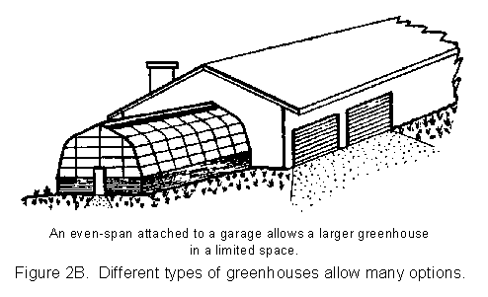
Figure2. 2 Greenhouse Types

Window-mounted
A window-mounted greenhouse can be attached on the south or east side of a house. This glass enclosure gives space for conveniently growing a few plants at relatively low cost (Figure 2.3). The special window extends outward from the house a foot or so and can contain two or three shelves.

Figure2. 3 Greenhouse Types

2.1.2 Freestanding Structures
Freestanding greenhouses are separate structures; they can be set apart from other buildings to get more sun and can be made as large or small as desired (Figure 2C). A separate heating system is needed, and electricity and water must be installed.
The lowest cost per square foot of growing space is generally available in a freestanding or even-span greenhouse that is 17 to 18 feet wide. It can house a central bench, two side benches, and two walkways. The ratio of cost to the usable growing space is good.
When deciding on the type of structure, be sure to plan for adequate bench space, storage space, and room for future expansion. Large greenhouses are easier to manage because temperatures in small greenhouses fluctuate more rapidly. Small greenhouses have a large exposed area through which heat is lost or gained, and the air volume inside is relatively small; therefore, the air temperature changes quickly in a small greenhouse. Suggested minimum sizes are 6 feet wide by 12 feet long for an even-span or freestanding greenhouse (Figure 2.4).

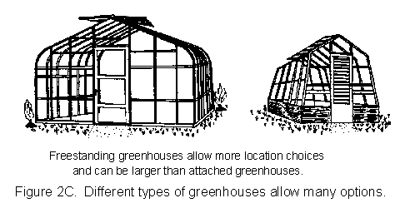
Figure2. 4 Freestanding Greenhouse

2.2 Structural Materials

A good selection of commercial greenhouse frames and framing materials is available. The frames are made of wood, galvanized steel, or aluminum. Build-it-yourself greenhouse plans are usually for structures with wood or metal pipe frames. Plastic pipe materials generally are inadequate to meet snow and wind load requirements. Frames can be covered with glass, rigid fiberglass, rigid double-wall plastics, or plastic film. All have advantages and disadvantages. Each of these materials should be considered--it pays to shop around for ideas.

2.2.1 Frames
Greenhouse frames range from simple to complex, depending on the imagination of the designer and engineering requirements. Figure 2.5 is several common frames;
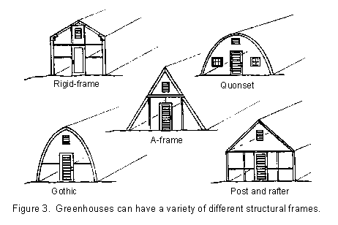

Figure2. 1 Frame Ranges

Quonset
The Quonset is a simple and efficient construction with an electrical conduit or galvanized steel pipe frame. The frame is circular and usually covered with plastic sheeting. Quonset sidewall height is low, which restricts storage space and headroom.

Gothic
The gothic frame construction is similar to that of the Quonset but it has a gothic shape. Wooden arches may be used and joined at the ridge. The gothic shape allows more headroom at the sidewall than does the Quonset.
Rigid-frame
The rigid-frame structure has vertical sidewalls and rafters for a clear-span construction. There are no columns or trusses to support the roof. Glued or nailed plywood gussets connect the sidewall supports to the rafters to make one rigid frame. The conventional gable roof and sidewalls allow maximum interior space and air circulation. A good foundation is required to support the lateral load on the sidewalls.

Post and rafter and A-frame
The post and rafter is a simple construction of an embedded post and rafters, but it requires more wood or metal than some other designs. Strong sidewall posts and deep post embedment are required to withstand outward rafter forces and wind pressures. Like the rigid frame, the post and rafter design allows more space along the sidewalls and efficient air circulation.

A-frame
The A-frame is similar to the post and rafter construction except that a collar beam ties the upper parts of the rafters together.

2.2.2 Coverings
Greenhouse coverings include long-life glass, fiberglass, rigid double-wall plastics, and film plastics with 1- to 3-year lifespan. The type of frame and cover must be matched correctly.

Glass
Glass is the traditional covering. It has a pleasing appearance, is inexpensive to maintain, and has a high degree of permanency. An aluminum frame with a glass covering provides a maintenance-free, weather-tight structure that minimizes heat costs and retains humidity. Glass is available in many forms that would be suitable with almost any style or architecture. Tempered glass is frequently used because it is two or three times stronger than regular glass. Small prefabricated glass greenhouses are available for do-it-yourself installation, but most should be built by the manufacturer because they can be difficult to construct.
The disadvantages of glass are that it is easily broken, is initially expensive to build, and requires must better frame construction than fiberglass or plastic. A good foundation is required, and the frames must be strong and must fit well together to support heavy, rigid glass.

Fiberglass
Fiberglass is lightweight, strong, and practically hails proof. A good grade of fiberglass should be used because poor grades discolor and reduce light penetration. Use only clear, transparent, or translucent grades for greenhouse construction. Tedlar-coated fiberglass lasts 15 to 20 years. The resin covering the glass fibers will eventually wear off, allowing dirt to be retained by exposed fibers. A new coat of resin is needed after 10 to 15 years. Light penetration is initially as good as glass but can drop off considerably over time with poor grades of fiberglass.

Double-wall plastic
Rigid double-layer plastic sheets of acrylic or polycarbonate are available to give long-life, heat-saving covers. These covers have two layers of rigid plastic separated by webs. The double-layer material retains more heat, so energy savings of 30 percent are common. The acrylic is a long-life, no yellowing material; the polycarbonate normally yellows faster, but usually is protected by a UV-inhibitor coating on the exposed surface. Both materials carry warranties for 10 years on their light transmission qualities. Both can be used on curved surfaces; the polycarbonate material can be curved the most. As a general rule, each layer reduces light by about 10 percent. About 80 percent of the light filters through double-layer plastic, compared with 90 percent for glass.

Film plastic
Film-plastic coverings are available in several grades of quality and several different materials. Generally, these are replaced more frequently than other covers. Structural costs are very low because the frame can be lighter and plastic film is inexpensive. Light transmission of these film-plastic coverings is comparable to glass. The films are made of polyethylene (PE), polyvinyl chloride (PVC), copolymers, and other materials. A utility grade of PE that will last about a year is available at local hardware stores. Commercial greenhouse grade PE has ultraviolet inhibitors in it to protect against ultraviolet rays; it lasts 12 to 18 months. Copolymers last 2 to 3 years. New additives have allowed the manufacture of film plastics that block and reflect radiated heat back into the greenhouse, as does glass which helps reduce heating costs. PVC or vinyl film costs two to five times as much as PE but lasts as long as five years. However, it is available only in sheets four to six feet wide. It attracts dust from the air, so it must be washed occasionally.

2.3 Foundations and Floor

Permanent foundations should be provided for glass, fiberglass, or the double-layer rigid-plastic sheet materials. The manufacturer should provide plans for the foundation construction. Most home greenhouses require a poured concrete foundation similar to those in residential houses. Quonset greenhouses with pipe frames and a plastic cover use posts driven into the ground.
Permanent flooring is not recommended because it may stay wet and slippery from soil mix media. A concrete, gravel, or stone walkway 24 to 36 inches wide can be built for easy access to the plants. The rest of the floor should be covered by several inches of gravel for drainage of excess water. Water also can be sprayed on the gravel to produce humidity in the greenhouse.

2.4 Location

The greenhouse should be located where it gets maximum sunlight. The first choice of location is the south or southeast side of a building or shade trees. Sunlight all day is best, but morning sunlight on the east side is sufficient for plants. Morning sunlight is most desirable because it allows the plant's food production process to begin early; thus growth is maximized. An east side location captures the most November to February sunlight. The next best sites are southwest and west of major structures, where plants receive sunlight later in the day. North of major structures is the least desirable location and is good only for plants that require little light.
Deciduous trees, such as maple and oak, can effectively shade the greenhouse from the intense late afternoon summer sun; however, they should not shade the greenhouse in the morning. Deciduous trees also allow maximum exposure to the winter sun because they shed their leaves in the fall. Evergreen trees that have foliage year round should not be located where they will shade the greenhouse because they will block the less intense winter sun. You should aim to maximize winter sun exposure, particularly if the greenhouse is used all year. Remember that the sun is lower in the southern sky in winter causing long shadows to be cast by buildings and evergreen trees.
Good drainage is another requirement for the site. When necessary, build the greenhouse above the surrounding ground so rainwater and irrigation water will drain away. Other site considerations include the light requirements of the plants to be grown; locations of sources of heat, water, and electricity; and shelter from winter wind. Access to the greenhouse should be convenient for both people and utilities. A workplace for potting plants and a storage area for supplies should be nearby.

2.5 The Building of “Smart Greenhouse”

In our project, we constructed prototype approximately 2 x 3 x 2,5meters (L x W x H) sized a lean-to greenhouse. Because of limited space and minimize financial expenses we preferred this type of greenhouse structure. The ridge of the lean-to is attached to the wall, and we use advantage of being closer to the resources such as electricity, water and heat. To protect landscape beauty we the lean-to doesn’t face the best direction for adequate sun exposure. Therefore we can not use sun light efficiently. By using the central heating and special light bulbs, which emits lights with suitable wavelength and intensity, we compensate this disadvantage.
Then we have considered the location of windows and doors on the supporting structure. To maximize circulation of air inside and to protect the greenhouse framework from snow, ice, or heavy rain conditions, we conclude the following structure shape, as you see the graph drawn in Catia (Figure 2.6), is 3D design software.
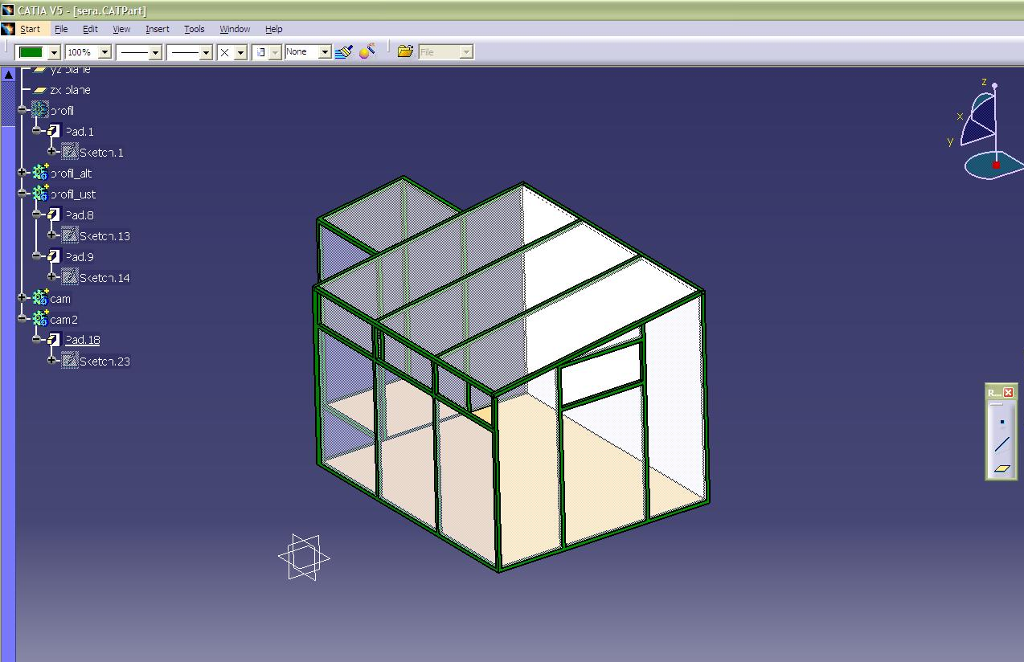
Figure 2. 2 Catia Model
Required mechanic actions are taken via pneumatic systems. Hydraulic systems are not enough clear, hygienic, for agricultural usage. And mechanic gearbox systems are not easy to implement and require more tunings than pneumatic system. However we use gearbox and 3 phase electric motor for shading mechanism. Because it requires more power and total cost for realizing such pneumatic scheme (Figure2.7) is not efficient that’s why we used pneumatic system. On the other hand air piston offers an integrated feedback proximity sensor, so we can check the accuracy of the action taken.

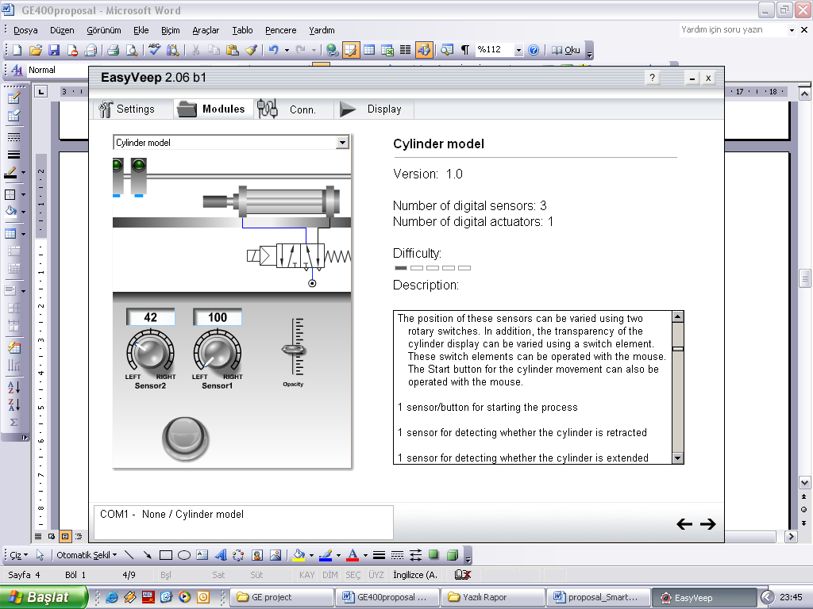
Pneumatic Controlled Side Vents
PLC controlled
2/1 Pneumatic valves
Side window closed-check switch
Figure2. 3 Pneumatic Controlled Side Vents
There are three different windows; one is winter window, other is side window, and the last is roof window. If the inner temperature is higher than the reference value, the expected value of the inner temperature, first winter window is opened, if it is not enough, inner temperature does not decrease in a certain time, and side window will be openedi see figure 2.8. If certain time passed and inner temperature does not drop off, the roof window will be opened. By this way, we reduce power consumption which is dissipated by pneumatic compressor and we minimize the temperature fluctuations and provide linear increasing and decreasing.

Inner temp
C°

Set value

Time

Winter window opened
Side window opened
Roof window opened
Roof window closed
Roof window opened
Roof window closed

Figure 2. 8 Temperature vs Window Positions

The greenhouse construction (Figure 2.9) will be made up of polycarbonate films between metal frameworks. Structural costs of such plastic coverings are very low because the frame can be lighter and plastic film is inexpensive. Polycarbonate films are made of different sizes and different thickness. While determining the dimensions of the framework, we have considered polycarbonate size standards. Moreover, polycarbonate films do not deteriorate from any weather condition. For example, it is strong enough to shield crops from snow, or transparent enough to pass sunlight and it reflect harm UV lights.
For the double-layer rigid-plastic sheet materials, permanent foundation is the best solution, because the PC (polycarbonate) film has long lifetime. Therefore we build steel foundation. Although permanent flooring is not recommended because it may stay wet and slippery from soil mix media, we build special floor that consists small gravels on 40-50 cm deep of the soil level.

Soil
Gravel
40cm
Permanent founding
250cm
Figure 2. 9 Greenhouse Construction

This small stones provide the drainage of the excess water. And we don’t prefer spraying system for irrigation, which results increase in the humidity of greenhouse. We make irrigation by special dripping system which makes available efficient use of the water resources also electrical resources.

- CONTROL PROCESS

There are many benefits that a fully automated greenhouse control systems bring to the grower. Obviously, there will be the labor saving aspect but far more importantly, factors such as improved quality of harvest and promote faster growth, increase yields, improve quality and reduce diseases.
The critical environmental parameters affecting plant growth that growers can control in the greenhouse are temperature, relative humidity, availability of water, and the growing media []. The way environment affects plant growth is not necessarily straightforward and the effect of one parameter is moderated by the others.
Control process includes automation of the environment, automation of fertilizer, automation of irrigation, automation of fogging, automation of climate, automation of system actuators monitoring and automation of light.
Automation of the environment consisting of systems that controlled by pneumatic valves and pistons, window position control systems, roof open position controlling, door position checking and integration of these parts as a whole concept.
Automation of fertilizer and fogging system is consisting of water tank, solenoid valves, liquid pump, plumbing mixer and atomizer.
Irrigation system contains water pump, liquid valves, irrigation plumbing, and system checking sensors.
The one of the most important part of system is climate. The greenhouse system is affected commonly by temperature, humidity, moisture, wind and sun light. Fan systems, pneumatic controlled windows, automatic heaters, air cooler system helped by fogging system are common parts of our greenhouse project.
Also special polycarbonate cover material supports climate by the impact resistance specification and protection from unexpected change of weather conditions.
By the error checking mechanism and feedback sensors; all system actuators are controlled by system as a result of various feedback sensors. In view of that these all the system responses can be monitored at any time and any situations.
Now we will express depth information about our system specifications and software algorithms.

3.1 Climate

One of the main tasks in greenhouse construction is to optimize the conditions for plant development, generally during the off-season from normal outside field production. [] The "internal" or greenhouse climate factors required for the optimal plant development involve photosynthesis and respiration.
Temperature, humidity and air circulations are measurable quantities of greenhouse. All these characteristics related each other. If a greenhouse controlled by automatically, system accordingly configure these parameters.
Some of the most important environmental ingredients are optimum humidity levels, maximum light levels, and ideal temperatures and reduced disease rates.
Traditionally the climate control in greenhouses is based on the inside air temperature and humidity. With smart greenhouse system is named Equinox introduces environmental control based on air, humidity and extra parameter soil temperature.
The temperature can be measured with the PT100 sensor. Pt 100 is the fundamental sensor of industrial temperature measurement. The temperature can be used as the main input for controlling of heating, cooling, curtains, misting and irrigation.
Humidity is transmitted with capacitive, thermal conductivity or resistive type of sensors. Measurement of humidity is another key subject of our system input.
Wind is another parameter for measurement. Also it is used for modifying windows and other climate equipment such as heater and fan positions very easily by PLC system.
Orientation, the structure itself, heating, and ventilation are key factors in having a successful greenhouse operation. [] PLC based heating, cooling, fogging for humidity, ventilations are our system capabilities for controlling climate parameters.

3.1.1 Heating & Cooling
Adding heat to a greenhouse can protect plants from freezing, speed germination, and accelerate. Also heating provide winter protection for tender plants, extend the normal growing season or to grow species from warmer climates.
There are several ways to heat a greenhouse: space heat, radiant heat, and/or zone heat. [] Space heat is simply heating the air, which in turn heats the soil and plants. When heating is required, the air will be 10 to 12 degrees warmer than the soil. Heaters should be controlled by an aspirated thermostat located near the center of the greenhouse and near the growing area.
After processing the Pt100 temperature sensors output signals converted via ADC (Analog to Digital converter) inside the PLC, if temperature value lower than set point, PLC system activate pneumatic valves and closes greenhouse windows. As in order, system firstly opens the smallest windows, than open side windows and lastly roof window. Actions are taken via powerful and anticorrosive pneumatics pistons.
However, temperature is lower than expected value, if the window are already opened, system close the again in the order of from larger to smaller. Then, space heater opens by PLC output. If all these action are not enough, system starts alarm.
Same method is used for cooling process. At this time temperature is higher than expected value, during this process, PLC activates pneumatic valves and open windows by same pistons. If it is not enough for cooling, fogging procedure steps in and temperature can be decreased inside the greenhouse system.

3.1.2 Ventilation
Every greenhouse should be equipped with air management systems. Air handling is key subject of greenhouse production sustain uniformly and effectively.
It allows for a more uniform climate and helps to distribute heat from the heating system as well as removing heat from the greenhouse when cooling is required[]
Automatic ventilation eliminates manual work and is the best way to cool a greenhouse. If your greenhouse has roof vents, for example, a thermostat and electric motor will open and close the vents.
One system is an air exchange system, or fans and louvers. If properly designed, natural ventilation can be effective but is more difficult to control. [] If the greenhouse is to be used during the summer months, it most likely needs to be equipped with exhaust fans that will deliver at least one air exchange per minute.
The second air handling system that should be in every greenhouse is for air circulation. Air circulation is important to maintain uniform conditions within the house, facilitate growing, and minimize disease losses. The circulation fans should be operated 24 hours every day unless ventilation fans are operating during the day. Continuous air circulation will minimize condensation problems.
At our system, exhaust fan, framework of a roof and winter window are main component part of its.
For air exchange, there are two options. One of them is fan system. The system is worked together with automatic windows and fogging system. When air humidity level is decrease, the fogging system works, immediately afterwards the fan works and air conditions is homogenized. By the way, air exchange is done.
Also inner temperature is homogenized by ventilation systems. Fan works at a regular time interval of day. It distributes temperature and makes well air requirement for crops without condensation problem.
There is an extra feature for natural ventilation system. Winter window supports air flow regulation when windy hours to protect greenhouse inside from harmful air flow.
Additionally roof framework is used sunny and high temperate hours to extra cooling and air flow regulation inside the greenhouse. PLC system management program is policy maker to opening or closing windows and roof.
All of these system parameters and components work together as a team player. By the way greenhouse air conditions and temperature level are stabilized within crops quality and customer prospects.

3.1.3 Humidity & Mist Systems
Another the smart greenhouse system function is humidifier with mist system. This system is used for cooling and increase it’s inside humidity ratio with water. This system is controlled by PLC as another system functions.
Typically all growers have a problem with low humidity and high temperatures. Serious problems occur when the humidity in the greenhouse environment drops below 30% RH. Plants will suffer and typically slow or stop the progress of the growing process. []
High and low-pressure mist systems (Figure 3.1) are used for cooling and adding humidity to the greenhouse. Mist systems can be employed in both automatically and naturally ventilated greenhouses.

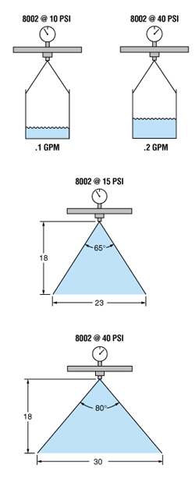
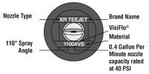
Figure 3. 1 Low-Pressure Mist System
Mist systems work by forcing water through nozzles at figure 2 which break up the water into fine droplets. This process allows the droplets to evaporate fairly quickly into the air. As the evaporation of water requires heat from the environment, the air is cooled.
Misting systems must be carefully controlled to provide the required cooling without increasing the relative humidity beyond optimum levels for plant performance, or allowing free water to form on the plants which can encourage the development of infection.
This system is fully controlled by PLC algorithm. When humidity sensor level is lower than set point, liquid valves activated 24 volt by PLC and fogging pump starts up. Finally water injected inside the tee jet and process successfully completes.

3.2 Irrigation

The fertilizer and irrigation systems provide control on the delivery of water and nutrients to the plants. The two systems complement each other to deliver precise at Figure 3.2 amounts of water and fertilizer to the plants as frequently as required.
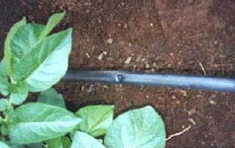
Figure 1.2 Dripping Pipe

Has proven to be a most efficient way of irrigation is an integral dripper in lateral spacing between drippers, starting from 20cm, with a flow rate starting from 1.2 l/h up to 4 l/h. The operation can be done by controller or by center PLC controlled.
The greenhouse project has irrigation system. The system has water tank, solenoid valves, dripping pipe and water pumps.
It works depending on soil humidity level. Soil moisture parameter is collected by special type of sensor and its data is collects PLC register. This variable is processed by software algorithm, and moisture level is adjudicated. If the soil moisture level does not met set value, the system runs and PLC activates pump and valves. By the way; soil moisture level automatically rearranges at set level.

3.3 Lighting

Light limits the photosynthetic productivity of all crops and is the most important variable affecting productivity in the greenhouse. []
(6 CO₂ + 12 HO - Light energy -> C₆H₁₂O₂ + 6 O₂ + 6 H₂O)
During off-day, the crops need light to keep growing. For these reason the smart greenhouse system has four special lamps which are suitable for crops.
The procedure of lightening system is based on sun light density. If the sunlight density is decrease under minimum growing level, the lamps open by PLC. Same way; when sunlight increase to sufficient level of growing, the lamps closed by PLC software again and system keep on regular operations.

3.4 Shading

The greenhouse needs shading tent to protect from harmful sunlight. Panels of greenhouse at Figure3.3 absorb the sunlight and the heat of sun increases the temperature in greenhouse. When the temperature is rising in greenhouse, we need to use a cloth to help lower the temperature in greenhouse. Combining the use of a shade tent with vents and fans keeps greenhouse cooler so that farmer can continue growing and starting plants in their greenhouse during the summer months. This is particularly important when they want to start their winter greenhouse garden in the months of July and August when the heat is coming on strong.

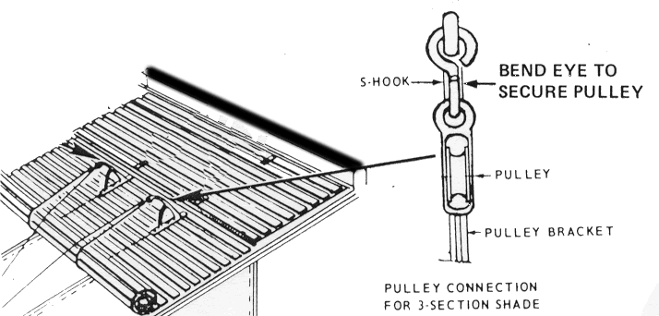
Figure 3.3 Shading Tent

Shade cloths partially block the sun, which decreases the temperature in greenhouse. Shade cloths can lower temperature inside the greenhouse by as much as twenty percent. Using a shade cloth in combination with vents and with fans you can keep the environment optimal for a great growing season.
The greenhouse is automatically controlled by PLC based software. When, sunlight heats it than the shading motor starts and shading tent open. Same method is used for closing shading tent. The tent closes when sunlight effect decreases suitable value. This controlled based on special (LDR) photo sensor.

3.5 Sensors

A sensor is a device to distinguish changes in the environment such as energy, heat, light, water, presence, and convert them to electric signals. In greenhouse systems, there are many types of sensors that are used for detecting different conditions, look table3.1 The following table shows the energy, intermediary and sensor type relation. There are some International Standard IEC 60529 outlines an international classification system that describes the sealing characteristics of electrical equipment. The classification system defines the level of protection provided by enclosures to prevent the ingress of foreign objects and moisture into the electrical equipment, see Appendix B for more information.

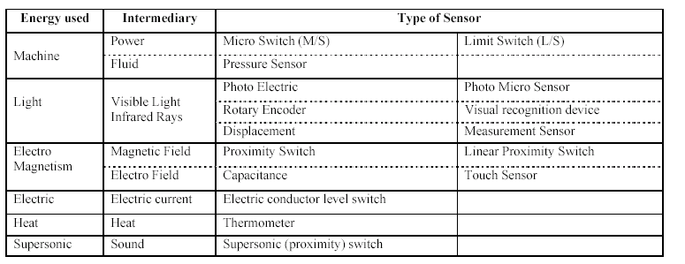
Table 3.1

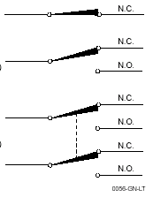
Output of these sensors can be either analog-answer the questions where is it? How much there? or digital- answer the question of is the target there? Output of the digital sensors can provided with electronic component-where high switching skill is required, or with electro magnetic relay- high power is switched and speed is not more than 50 Hz. An electromechanical relay (or dry contact) is actuated by energizing a wire coil which magnetically attracts an armature to physically open and close a circuit. When the circuit is open, no power is conducted across the contacts. When the circuit is closed, power is conducted to the load. A relay with an open contact in the rest (or un-energized) state is considered normally open, whereas a relay with a closed contact in the rest state is Normally Closed, the contact connection of the relay is shown in figure3.2 Because of the electrical isolation from the power source of the sensor and due to the absence of leakage current, relays from multiple sources can readily be connected in series and/or parallel to switch AC or DC loads.

Figure3. 1 Contact Types

In the greenhouse applications the speed of the actions slow and there are a few number of actions are taken daily. Relay output sensors can be used confidently. You can see the digital sensors, which used in the greenhouse automation.
- Limit switch
- Rain sensor
- Light sensor
- Wind sensor (with processor support)
- Liquid tanks level switches
- Watering check switch
- Proximity Sensor
- Piston reed sensor

Also there are some analog output sensors for process control system.
  - Air Humidity
  - Soil Humidity
  - Temperature Transmitters

3.5.1 Limit Switch
The contacts of a limit switch change state when a predetermined force or torque is applied to the actuator. A spring return (momentary) switch returns its contacts to their original position when the operating force is removed. The contacts of a maintained switch remain in the actuated position until force or torque is applied in the opposite direction.

Advantages
The mechanical advantages of limit switches are;
• Ease of use
• Simple visible operation
• Durable housing
• Well sealed for reliable operation
• High resistance to different ambient conditions found in industry
• High repeatability
• Positive opening operation of contacts (some models)

The electrical advantages of limit switches are:
• Suitable for switching higher power loads than other sensor technologies (5A at 24V DC or 10A at 120V AC typical vs. less than 1A for proximities or photoelectric)
• Immunity to electrical noise interference
• Immunity to radio frequency interference (walkie-talkies)
• No leakage current
• Minimal voltage drops
• Simple Normally Open and/or Normally Closed operation

Disadvantages
The disadvantages of limit switches are:
• Shorter contact life than solid-state technology
• Moving mechanical parts wear out eventually
• Not all applications can use contact sensing

Limit switches can manipulate either 12V or 220 VAC. In our automation system we used limit switches for taking feedback from actions. And to check door position we used limit switch. Because of their lower we just bought them for our project.

3.5.2 Rain Sensor
To protect greenhouse framework and crops in the greenhouse we take precaution before rain. We don’t need any analogue output, so we implement digital output rain sensor figure 3.3. To minimize the total expense of the project we design our own sensors. You can reach the circuit schematics from Appendix-B. If a drop of water fall into sense plate, the output voltage level rise from 0 to 24 V. Same while output is at 24 V level, the heater component turn on and it accelerates the vaporization time.

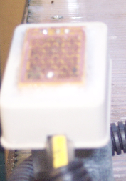
Figure 3. 3 Rain Sensor

3.5.3 Wind Sensor
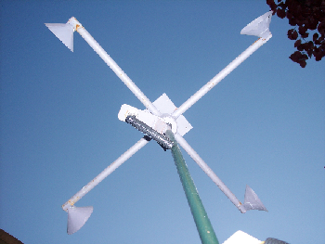
By using one proximity sensor and rolling mechanism as wind vane figure 3.4. We measure the number of tour per unit time, It is over than 60 rpm, and this action repeated itself three times in 15 minutes, processor consider the as windy. By this way, system does not activate the wind precautions, by this way we decrease the energy consumption for the systems.
Figure3. 4 Wind Sensor

3.5.4 Temperature Sensor
We used PT100 figure3.5, which is a component whose resistance value varies dependent to temperature of the environment, to measure inner or outer temperature. The relationship between temperature and resistance is approximately linear over a small temperature range: for example, if you assume that it is linear over the 0 to 100 C range, the error at 50C is 0.4 C. For precision measurement, it is necessary to linearism the resistance to give an accurate temperature.
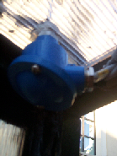
Figure3. 5 Temperature Sensor

The most recent definition of the relationship between resistance and temperature is International Temperature Standard 90 (ITS-90). This linearization is done automatically, in software, when using Pico signal conditioners. The linearization equation is
Rt = R0 * (1 + A* t + B*t2 +C*(t-100)* t3)
A = 3.9083 E-3
B = -5.775 E-7
C = (below 0 C) -4.183 E -12
(Above 0 C) zero
For a PT100 sensor, a 1 C temperature change will cause a 0.384ohm change in resistance, so even a small error in measurement of the resistance (for example, the resistance of the wires leading to the sensor) can cause a large error in the measurement of the temperature. For precision work, sensors have four wires- two to carry the sense current, and two to measure the voltage across the sensor element. It is also possible to obtain three-wire sensors, although these operate on the (not necessarily valid) assumption that the resistance of each of the three wires is the same.
The current through the sensor will cause some heating: for example, a sense current of 1mA through a 100 ohm resistor will generate 100uW of heat. If the sensor element is unable to dissipate this heat, it will report an artificially high temperature. This effect can be reduced by either using a large sensor element, or by making sure that it is in good thermal contact with its environment.
Using a 1mA sense current will give a signal of only 100mV. Because the change in resistance for a degree celsius is very small, even a small error in the measurement of the voltage across the sensor will produce a large error in the temperature measurement. For example, a 100uV voltage measurement error will give a 0.4 C error in the temperature reading. Similarly, a 1uA error in the sense current will give 0.4 C temperature error.
We used constant current source with single transistor (BJT), then this current flows through the PT100 and. The voltage on the PT 100 is carried to PLC’s analogue input modules. PT100 resistance is equal to 100Ω at 0C°. We flow constant 10mA current and at 0C° there is 1 V at the output of the transmitter.

3.5.5 Alarm Buzzer
To urge the operator and monitoring the errors occurred on the system we use both alarm light and alarm buzzer at figure 3.6. The buzzer circuit placed at the appendix- b part. There is voice amplifier integrated circuit and one oscillator. The supply voltage is 24 V and we decrease it to 12 volts, with 7812 regulation IC.

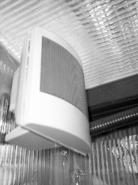
Figure3. 6 Alarm

3.5.6 Light Sensor
To detect lower limit of sun light that required, we implement a light limit switch shown at figure 3.7. There are two potentiometers on the circuit, and you can make necessary tuning with these variable resistors.
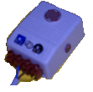
Figure3. 7 Light Sensor

3.5.7 Air Humidity Sensor
The Honeywell HIH V436 type capacitive humidity sensor shown as figure 3.8 is a kind of three legged sensor with 5 V supply voltage. This is the most we construct 24V to 5V regulator circuit with regulator IC 7805 and couple of capacitors. If the water percentage on the air increase, the middle leg, output voltage increase respectfully.
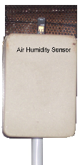
Figure3. 8 Air Humidity Sensor

4 PROCESS INTEGRATION

4.1 Software Integration

Mainly there are four environmental process controls in smart greenhouse system. Each system obtains their reference values from operator panel, or if receipt based automation is applied, from its database. Process algorithms try to remain their reference values, to achieve they manipulate the actuator and equipments in the greenhouse. Each system implement their functions independent from each other, if there is a collision while changing the position of an output, we assign a priority level to process and the action is taken according to the priority of the process that tries to change an output.
To make entering a reference value to the system, we prefer touch screen operator panel, other words HMI. Although, it is the best solution to satisfy costumer demands, it’s price is too expensive. Therefore we make up our decision and decide using functional operator panel.
In our system day time based application can be run. For example if you don’t have soil moisture sensor, you may want to start watering pump every Monday and Friday in the evening at 20:00.
In addition to process control actions, system measures the wind speed via proximity on the wind vane. Its intelligent side is; if there is single gust, the system does not make any action, because it is too late. To take precaution for this type of weather conditions, program counts the rising edges in certain time. If the number of rising edges is higher than a definite number system assume it is a stormy weather and close its all window immediately.

4.2 Receipt Based Automation

Different from the casual system capabilities, smart greenhouse system is able to memorize plant grooving condition parameters, and applies independent from the environment. First you register the related data block to PLC than you turn the control switch to receipt mode, then system will implement all required actions without any human intervention. The receipts include a small number of state variables and short computing times. These values are to be used in real time greenhouse climate control.

By installing the environmental condition parameters to the PLC, system provide the ideal circumstance for related crop independent from the operator, receipt mode. With this system user don not need to know much more about agricultural issues to grow a plant.
By this way producer ensure a standard in agriculture. Moreover s/he can estimate the total amount of resources dissipated for the related crop. This seems very advantageous in the management of large scale greenhouses. Moreover this will minimize the consumption of pesticide, fertilizer, so that encourage the organic agriculture.

CONCLUSION

As a result, we have built PLC based greenhouse automation that support all type of equipment used in greenhouse and able to evaluate analogue, humidity, temperature etc. and digital, rain sensor, light sensor, position check switch etc. inputs.
Today’s greenhouse control systems designed for only one process; to control more than one process simultaneously you have to buy more that one machine, so it will cost the costumer expensive. Our controller is able to manage all types of control processes simultaneously. By this way, total cost for complete solution is decreased. On the other hand, the system does not require any additional measurement device, it has built-in measurement algorithms and electronic devices.
The system is implemented by pneumatic actuator, so the control system is clear, safe, and easy to implement. By taking feedback signals from the position, irrigation check, etc. sensors the PLC decide if the action is realized accurately. If there is something wrong, operator/user is instantly informed by the operator panel, alarm light and buzzer.
Consequently, with using more efficient agricultural methods, total expenses for resources is decreased, and less employment is used, so general spending decreased. By special algorithms operator safety, alarm functions, intelligent measurements, built-in plant profile is realized. Moreover, all these are achieved with faultless and intelligent control system.

APPENDIX A

Basis of IP Rating System
International Standard IEC 60529 outlines an international classification system that describes the sealing characteristics of electrical equipment. The classification system defines the level of protection provided by enclosures to prevent the ingress of foreign objects and moisture into the electrical equipment. The classification system uses the “IP” code, or “Ingress Protection” code, to define the level of seal. The IP code uses a system of two numerical digits to define the level of both foreign object and moisture protection. Although the IP classification is primarily used for establishing the level of seal in electrical equipment, it is adapted herein for determining the level of seal in passive electrical components.

Degrees of Protection (Foreign Bodies) – 1st Digit
The first digit of the IP code indicates the degree of protection against solid foreign objects from entering the electrical device. The table below outlines the level of protection against foreign objects for each level.

Degrees of Protection (Moisture) – 2nd Digit
The second digit of the IP code indicates the degree of protection against the ingress of various forms of moisture. (e.g. drip, spray, submersion, etc.) into the component. Tests to determine the level of protection are carried out with fresh water and do not take into account the use of solvents.

IP Level; 1st Digit Description of Protection Level
0 | Not protected
1 | Protected against solid foreign objects of 50 mm diameter and greater
2 | Protected against solid foreign objects of 12,5 mm diameter and greater
3 | Protected against solid foreign objects of 2,5 mm diameter and greater
4 | Protected against solid foreign objects of 1,0 mm diameter and greater
5 | Protected from the amount of dust that would interfere with normal operation
6 | Dust tight

IP Level; 2nd Digit
0  1  2  3  4  5  6  7  8 | Not protected  Protected against vertically falling water drops  Protected against vertically falling water drops when enclosure is tilted up to 15 °  Protected against water sprayed at an angle up to 60 ° on either side of the vertical  Protected against water splashed against the component from any direction  Protected against water projected in jets from any direction  Protected against water projected in powerful jets from any direction  Protected against temporary immersion in water  Protected against continuous immersion in water, or as specified by the user

A component with this IP code indicates that a component is protected against ingress of solid foreign objects having a diameter of 2,5 mm and greater; and is protected against harmful effects due to water splashed against the component from any direction.

IP Code Symbols
This chart is based on an internationally recognized set of symbols that graphically represent the IP classification system. These symbols are sometimes used instead of the IP code to illustrate the level of protection.

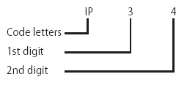
Figure A1.1

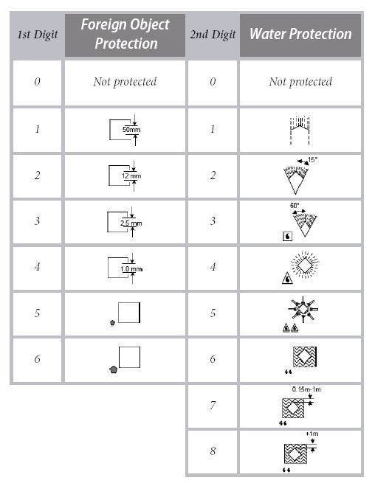
Figure A1.2

APPENDIX B
Electronic Schematics
FigureA2.1 is the rain sensor that used to detect rain drops, if water drops on the plate, 2W resistor behind, mounted, the plate start heating, because relay is trigged. It accelerates evaporation. A certain time( from 25sec to 30 min) later, plate completely dries and relay contact releases and heating stops.

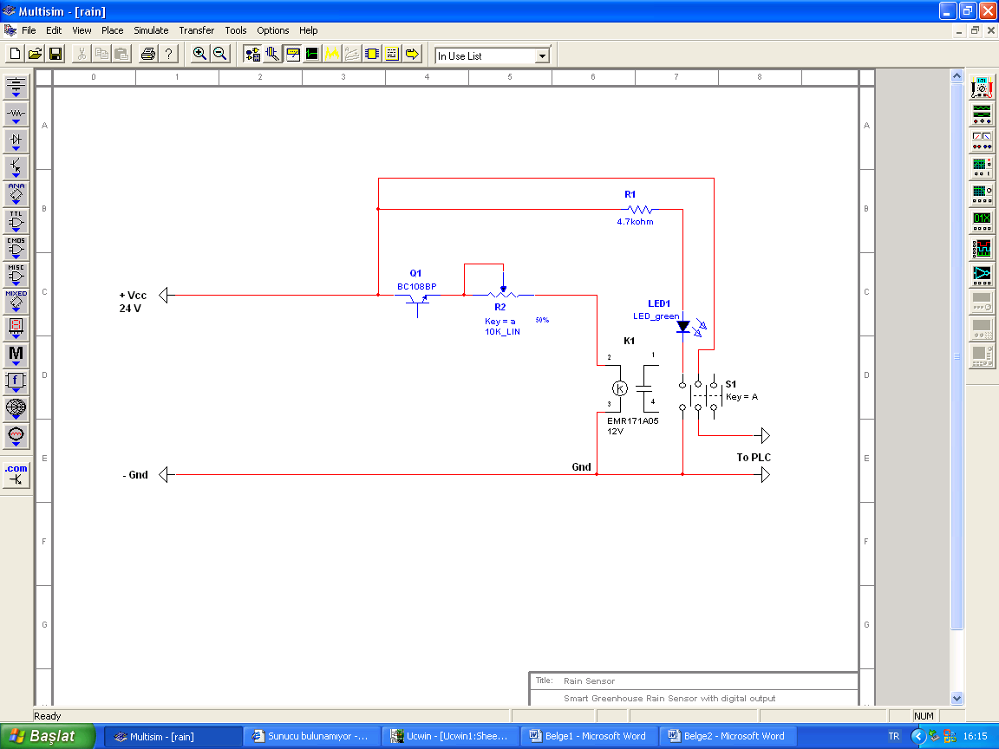
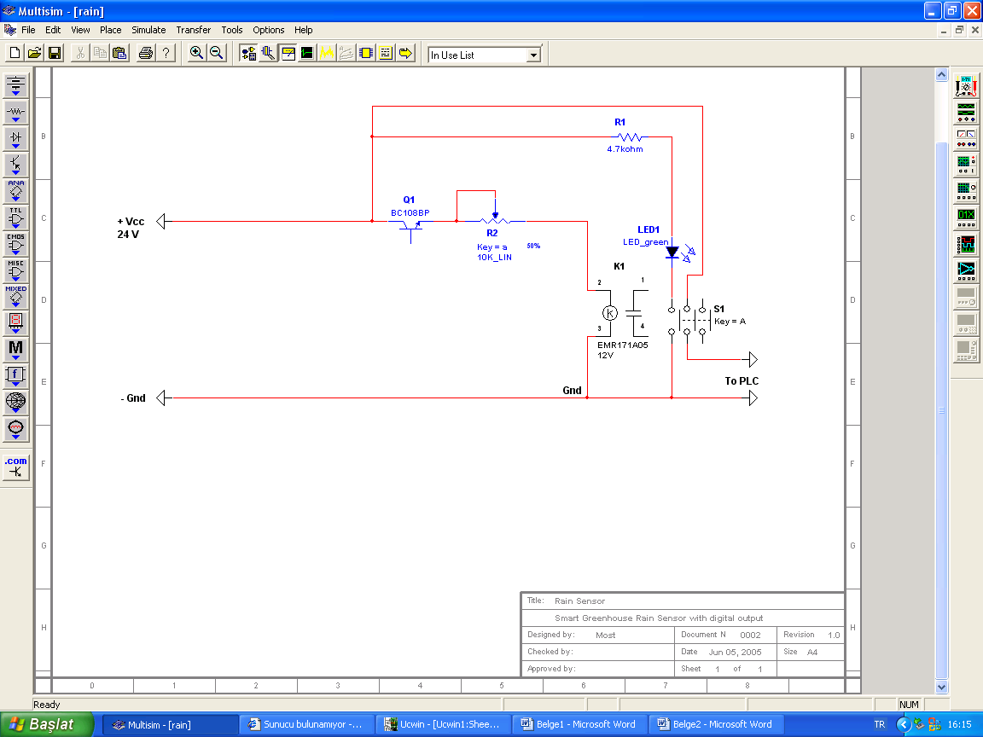

Figure A2.1
Sensing plate

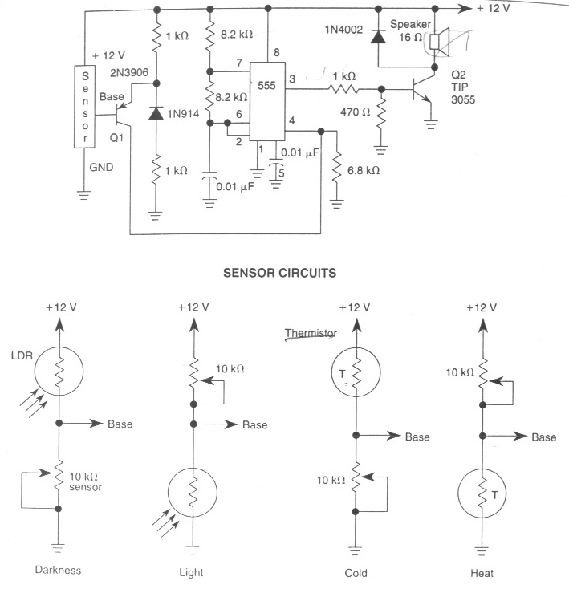
Figure A2.2
Figure A2.2 is a basic circuit to detect environmental conditions. Selective circuit can be used with different combinations; we used dark detective part with connecting a relay at the out put. On the other hand, output stage, square wave oscillator, is used an alarm circuit separately.
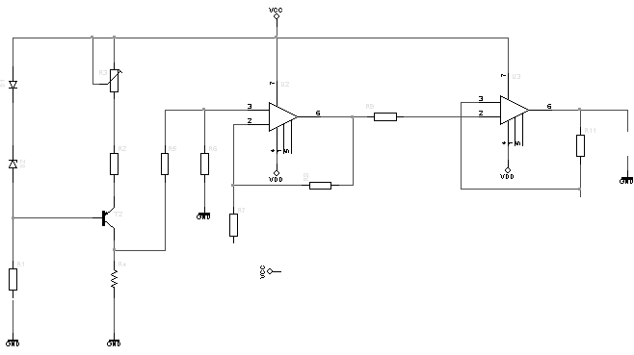
Figure a2.3 is an PT100 to voltage converting circuit. There is a constant current source that flows 10mA over PT100. Resistance of PT100 varies depending on temperature. While the resistance changes, the voltage across the PT100 varies. This voltage differentiation is evaluated by PLC as an analog input.
Figure A2.3
PT100

APPENDIX C
Troubleshooting Guide

The Irrigation:
If the irrigation does not start,
- Check the water in the tank 1
  - If the tank is empty, check the valve and the water presence in the input pipe
  - If the tank is full, see the next step
- Control the irrigation pump
  - If the irrigation pump does not work, check the voltage on the input wires and pump cable
  - If the irrigation pump is working, see the next step
- Check the irrigation sensor,
  - If the irrigation sensor does not turned on, control the sensor cable
  - If the irrigation sensor is working, see the next step

The Disinfection:
If the disinfection does not working,
- Check the water in the tank 2
  - If the tank is empty, check the valve and the water presence in the input pipe
  - If the tank is full, see the next step
- Control the disinfection pump
  - If the disinfection pump does not work, check the voltage on the input wires and pump cable
  - If the disinfect pump is working, see the next step
- Check the disinfection sensor,
  - If the disinfection sensor does not turned on, control the sensor cable
  - If the disinfection sensor is working, see the next step
- Control the disinfection mixer,
  - If the disinfection mixer does not rotating, the pipe coming from the other tank may roll over the mixer
  - If the disinfection mixer is working, see the next step

Shading:
If the volume reducer does not working,
- Check the tightness of the steel rope,
  - If it is over tight, reduce the tightness by using mechanism on the rope
  - If it is under tight, increase the tightness by using mechanism on the rope
  - If it is normal, see the next step
- Control the volume reducer motor,
  - If the volume reducer motor is not working, check the voltage on the input wires, motor cable and motor oil, control the shading tent
  - If it is working, see next step
- Check the proxy,
  - If the proxy is not working, check the voltage on the input wire
  - If it is working, see next step

The Heating:
If the radiator does not working,
- Check power button on the radiator
  - If the power button is close, turn on
  - If it is working, see next step
- Check the voltage on the input wires and radiator cable

The Illumination:
If the lights do not work,
- Control the socket,
  - If the lamb is not plugged well, fit the lamb into the socket
  - If the lamb is plugged well, see next step
- Check the lights cables,
  - If the cables are not connected, report the system administrator
  - If they are connected, see next step
- Check the lights sensor,
  - If the light sensor does not turned on, control the sensor cable
  - If the light sensor is working, see the next step
Alarm Lamb:
If the alarm lamb does not work,
- Control the socket,
  - If the alarm lamb is not plugged well, fit the lamb into the socket
  - If the lamb is plugged well, see next step
- Check the lamb cables,
  - If the cables are not connected, report the system administrator
  - If they are connected, see next step

The Windows:
If there is a problem on the windows system,
- Control windows pneumatic connection,
  - If the air hose is not connected, plug it
  - If system connection is normal, see next step
- Control the wind sensor,
  - If the wind sensor’s proxy does not work, replaced.
  - If the wind sensor’s proxy is working, see next step
- Control the rain sensor,
  - If the rain sensor does not work, replaced.
  - If the rain sensor is working, see next step
- Check the windows proxy,
  - If the window sensor’s proxy does not work, replaced.
  - If the window sensor’s proxy is working, see next step
REFERENCES

[1] Both, J., Creating a Master Plan for Greenhouse Operations
[2] Disposal Report, Producers of California, 1997
[3] http://www.greenbeam.com/features/they111802.stm
[4] Fall and Winter Vegetable Gardening, Community Horticulture Fact Sheet #41.
http://www.metrokc.gov/wsu-ce/Gardening/GardenResources/Fact-Sheets
/41-FallWinter.htm
[5] Kantor, S., WSU Cooperative Extension King County, 1999
[6] David S. Ross, Adapted from Fact Sheet 645 - University of Maryland Cooperative Extension Service, Extension Agricultural Engineer, Department of Agricultural Engineering
[7] Gene, A. Giacomelli and William, J.R., Department of Bioresource Engineering Rutgers University Cook College, New Brunswick, NJ 08903
[8] Encyclopedia of Electronic Circuits Vol: 1, 3, 5
[9] http://www.htservices.com/Tools/control_engines.htm
[10] http://www.commercial-greenhouse-equipment.com/home.htm
[11] http://www.honeywell.com.tr
[12] http://www.sick.com
[13] http://www.maxim.com
[14] http://www.cample.com
[15] http://www.toraman.ca/
[16] http://www.texasgreenhouse.com/Garden/
[17] http://www.microgrow.com/

Argus Control Systems Ltd. is the leader Company about Greenhouse Controls, in Canada.
www.disposalreport.com
http://www.greenbeam.com/features/they111802.stm
see Fall and Winter Vegetable Gardening, Community Horticulture Fact Sheet #41, http://www.metrokc.gov/wsu-ce/Gardening/GardenResources/Fact-Sheets/41-FallWinter.htm
Stanghellini and Van Meurs 1992
Kiril Popovski Greenhouse Climate Factors http://geoheat.oit.edu/bulletin/bull18-1/art36.htm.
Greenhouse Engineering Gerald Christenbury
www.clemson.edu/peedeerec/Tobacco/ 2005TobGuideSections/GREENHOUSE_ENGINEERING.PDF
Greenhouse Engineering Gerald Christenbury
www.clemson.edu/peedeerec
http://www.coolingline.com/a-greenhouse.html
http://www.dagan.co.il/e_main.htm

