Theory of Inventive Problem Solving (TRIZ)

1.0 Introduction
Following World War II, the high quality, technologically advanced products of the United States dominated world markets. With the oil shock of the 1970s, however, many of the economic advantages associated with cheap petroleum were lost and the recovered economies of Europe and Asia emerged as strong competitors in many product areas. The innovative technologies of the US could no longer insulate industries from the customer oriented approaches of European and Asian producers.
The 1990s have seen the recovery of many US industries, most notably the automotive industry. This has been due in part to the influence of many Japanese quality methodologies introduced here by the late Dr. Kaoru Ishikawa, Dr. Masao Kogure, Dr. Yoji Akao, Dr. Noriaki Kano, Mr. Masaaki Imai, and many others. These quality methods have helped US industries reduce defects, improve quality, lower costs, and become more customer focused. As the quality gap with countries like Japan gets smaller, the US is looking for new approaches to assure customer satisfaction, reduce costs, and bring products to the market faster. In the US, we say "better, cheaper, faster."
While there are many widely used design and development approaches such as Quality Function Deployment, these show us what to solve but not always how to solve the technology bottlenecks that arise. One technique, the Reviewed Dendrogram, relies on the experience of designers which may be limited to certain areas of expertise such as chemistry or electronics. Thus, a solution that might be simpler and cheaper using magnetism could be missed. For example, a materials engineer searching for a dampener may limit his search to rubber based materials. A more efficient solution might lie in creating a magnetic field. Since this is outside the experience of the engineer, how could he imagine such a solution? Using TRIZ, he would be able to explore design solutions in fields other than his own.
Rockwell International's Automotive Division faced a problem like this. They were losing a competitive battle with a Japanese company over the design of brakes for a golf cart. Since both Rockwell and the Japanese competitor were in the automotive field, they were competing on redesigns of an automobile brake system but with smaller components. In TRIZ, this seeking solutions only in one's field is called "psychological inertia" because it is natural for people to rely on their own experience and not think outside their specialty. With TRIZ, the problem was solved by redesigning a bicycle brake system with larger components. The result was a part reduction from twelve to four parts and a cost savings of 50%.

2.0 The History of TRIZ
There are two groups of problems people face: those with generally known solutions and those with unknown solutions. Those with known solutions can usually be solved by information found in books, technical journals, or with subject matter experts. These solutions follow the general pattern of problem solving shown in figure 1. Here, the particular problem is elevated to a standard problem of a similar or analogous nature. A standard solution is known and from that standard solution comes a particular solution to the problem. For example, in designing a rotating cutting machine(my problem), a powerful but low 100 rpm motor is required. Since most AC motors are high rpm (3600 rpm), the analogous standard problem is how to reduce the speed of the motor. The analogous standard solution is a gear box or transmission. Then, a gear box can be designed with appropriate dimensions, weight, rpm, torque, etc. can be designed for my cutting needs.
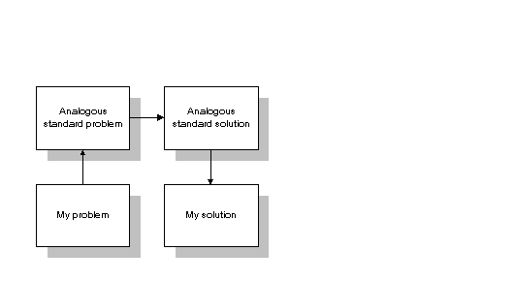
Figure 1. General Problem Solving Model.

2.1 Inventive Problems
The other type of problem is one with no known solution. It is called an inventive problem and may contain contradictory requirements. As long ago as the 4th century, an Egyptian scientist named Papp suggested there should be a science called heuristics to solve inventive problems. In modern times, inventive problem solving has fallen into the field of psychology where the links between the brain and insight and innovation are studied. Methods such as brainstorming and trial-and-error are commonly suggested. Depending on the complexity of the problem, the number of trials will vary. If the solution lies within one's experience or field, such as mechanical engineering, than the number of trials will be fewer. If the solution is not forthcoming, then the inventor must look beyond his experience and knowledge to new fields such as chemistry or electronics. Then the number of trials will grow large depending on how well the inventor can master psychological tools like brainstorming, intuition, and creativity. A further problem is that psychological tools like experience and intuition are difficult to transfer to other people in the organization.
This leads to what is called psychological inertia, where the solutions being considered are within one's own experience and do not look at alternative technologies to develop new concepts. This is shown by the psychological inertia vector in figure 2.
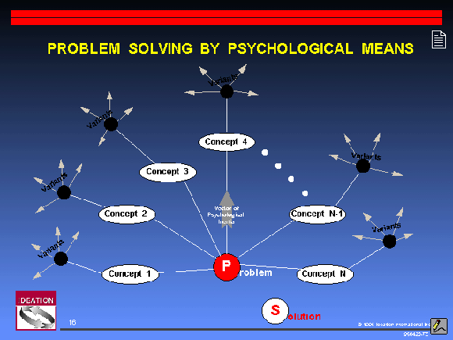
Figure 2. Limiting Effects of Psychological Inertia.
When we overlay the limiting effects of psychological inertia on a solution map covering broad scientific and technological disciplines, we find that the ideal solution may lie outside the inventor's field of expertise. This is seen in figure 3 where the ideal solution is electromechanical but is outside the experience of the mechanical engineer and so remains untried and may even be invisible. If problem solving was a random process, then we would expect solutions to occur randomly across the solution space. Psychological inertia defeats randomness and leads to looking only where there is personal experience.

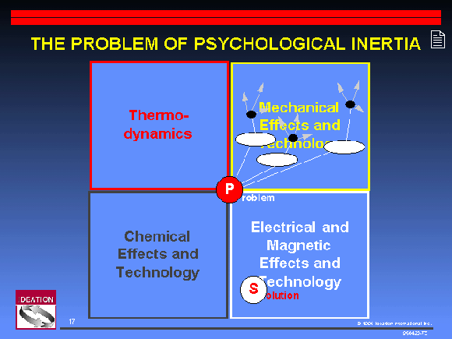
Figure 3. Ideal Solution May Be Outside Your Field.

2.2 Genrich S. Altshuller, the Father of TRIZ
A better approach, relying not on psychology but on technology was developed by Genrich S. Altshuller, born in the former Soviet Union in 1926. His first invention, for scuba diving, was when he was only 14 years old. His hobby led him to pursue a career as a mechanical engineer. Serving in the Soviet Navy as a patent expert in the 1940s, his job was to help inventors apply for patents. He found, however, that often he was asked to assist in solving problems as well. His curiosity about problem solving led him to search for standard methods. What he found were the psychological tools that did not meet the rigors of inventing in the 20th century. At a minimum, Altshuller felt a theory of invention should satisfy the following conditions:
- be a systematic, step-by-step procedure
- be a guide through a broad solution space to direct to the ideal solution
- be repeatable and reliable and not dependent on psychological tools
- be able to access the body of inventive knowledge
- be able to add to the body of inventive knowledge
- be familiar enough to inventors by following the general approach to problem solving in figure 1.
In the next few years, Altshuller screened over 200,000 patents looking for inventive problems and how they were solved. Of these (over 1,500,000 patents have now been screened), only 40,000 had somewhat inventive solutions; the rest were straight forward improvements. Altshuller more clearly defined an inventive problem as one in which the solution causes another problem to appear, such as increasing the strength of a metal plate causing its weight to get heavier. Usually, inventors must resort to a trade-off and compromise between the features and thus do not achieve an ideal solution. In his study of patents, Altshuller found that many described a solution that eliminated or resolved the contradiction and required no trade-off.
Altshuller categorized these patents in a novel way. Instead of classifying them by industry, such as automotive, aerospace, etc., he removed the subject matter to uncover the problem solving process. He found that often the same problems had been solved over and over again using one of only forty fundamental inventive principles. If only later inventors had knowledge of the work of earlier ones, solutions could have been discovered more quickly and efficiently.
In the 1960s and 1970s, he categorized the solutions into five levels.
- Level one. Routine design problems solved by methods well known within the specialty. No invention needed. About 32% of the solutions fell into this level.
- Level two. Minor improvements to an existing system, by methods known within the industry. Usually with some compromise. About 45% of the solutions fell into this level.
- Level three. Fundamental improvement to an existing system, by methods known outside the industry. Contradictions resolved. About 18% of the solutions fell into this category.
- Level four. A new generation that uses a new principle to perform the primary functions of the system. Solution found more in science than in technology. About 4% of the solutions fell into this category.
- Level five. A rare scientific discovery or pioneering invention of essentially a new system. About 1% of the solutions fell into this category.
He also noted that with each succeeding level, the source of the solution required broader knowledge and more solutions to consider before an ideal one could be found. His findings are summarized in Table 1.
Table 1. Levels of Inventiveness.
Level | Degree of inventiveness | % of solutions | Source of knowledge | Approximate # of solutions to consider
1 | Apparent solution | 32% | Personal knowledge | 10
2 | Minor improvement | 45% | Knowledge within company | 100
3 | Major improvement | 18% | Knowledge within the industry | 1000
4 | New concept | 4% | Knowledge outside the industry | 100,000
5 | Discovery | 1% | All that is knowable | 1,000,000
What Altshuller tabulated was that over 90% of the problems engineers faced had been solved somewhere before. If engineers could follow a path to an ideal solution, starting with the lowest level, their personal knowledge and experience, and working their way to higher levels, most of the solutions could be derived from knowledge already present in the company, industry, or in another industry.
For example, a problem in using artificial diamonds for tool making is the existence of invisible fractures. Traditional diamond cutting methods often resulted in new fractures which did not show up until the diamond was in use. What was needed was a way to split the diamond crystals along their natural fractures without causing additional damage. A method used in food canning to split green peppers and remove the seeds was used. In this process, peppers are placed in a hermetic chamber to which air pressure is increased to 8 atmospheres. The peppers shrink and fracture at the stem. Then the pressure is rapidly dropped causing the peppers to burst at the weakest point and the seed pod to be ejected. A similar technique applied to diamond cutting resulted in the crystals splitting along their natural fracture lines with no additional damage.
Altshuller distilled the problems, contradictions, and solutions in these patents into a theory of inventive problem solving which he named TRIZ.

3.0 TRIZ:

The Theory of Inventive Problem Solving
There are a number of laws in the theory of TRIZ. One of them is the Law of Increasing Ideality. This means that technical systems evolve toward increasing degrees of ideality, where ideality is defined as the quotient of the sum of the system's useful effects, U_{i}, divided by the sum of its harmful effects, H_{j}.
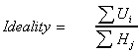
Useful effects include all the valuable results of the system's functioning. Harmful effects include undesired inputs such as cost, footprint, energy consumed, pollution, danger, etc. The ideal state is one where there are only benefits and no harmful effects. It is to this state that product systems will evolve. From a design point of view, engineers must continue to pursue greater benefits and reduce cost of labor, materials, energy, and harmful side effects. Normally, when improving a benefit results in increased harmful effects, a trade-off is made, but the Law of Ideality drives designs to eliminate or solve any trade-offs or design contradictions. The ideal final result will eventually be a product where the beneficial function exists but the machine itself does not. The evolution of the mechanical spring-driven watch into the electronic quartz crystal watch is an example of moving towards ideality.

3.1 The TRIZ Process Step-By-Step
As mentioned above, Altshuller felt an acceptable theory of invention should be familiar enough to inventors by following the general approach to problem solving shown in figure 1. A model was constructed as shown in figure 4.
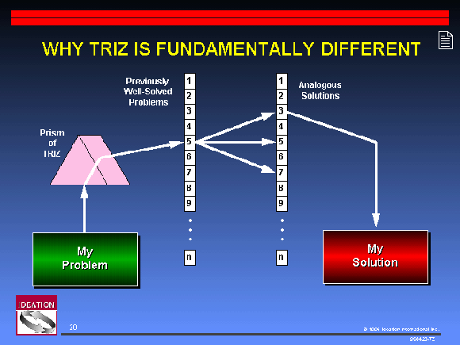
Figure 4. TRIZ Approach to Problem Solving.

3.1.1 Step 1. Identifying My Problem.
Boris Zlotin and Alla Zusman, principles TRIZ scientists at the American company Ideation and students of Altshuller have developed an "Innovative Situation Questionnaire" to identify the engineering system being studied, its operating environment, resource requirements, primary useful function, harmful effects, and ideal result.
Example: A beverage can. An engineered system to contain a beverage. Operating environment is that cans are stacked for storage purposes. Resources include weight of filled cans, internal pressure of can, rigidity of can construction. Primary useful function is to contain beverage. Harmful effects include cost of materials and producing can and waste of storage space. Ideal result is a can that can support the weight of stacking to human height without damage to cans or beverage in cans.

3.1.2 Formulate the problem: the Prism of TRIZ
Restate the problem in terms of physical contradictions. Identify problems that could occur. Could improving one technical characteristic to solve a problem cause other technical characteristics to worsen, resulting in secondary problems arising? Are there technical conflicts that might force a trade-off?
Example: We cannot control the height to which cans will be stacked. The price of raw materials compels us to lower costs. The can walls must be made thinner to reduce costs, but if we make the walls thinner, it cannot support as large a stacking load. Thus, the can wall needs to be thinner to lower material cost and thicker to support stacking-load weight. This is a physical contradiction. If we can solve this, we will achieve an ideal engineering system.

3.1.3 Search for Previously Well-Solved Problem
Altshuller extracted from over 1,500,000 world-wide patents these 39 standard technical characteristics that cause conflict. These are called the 39 Engineering Parameters shown in Table 2. Find the contradicting engineering principles. First find the principle that needs to be changed. Then find the principle that is an undesirable secondary effect. State the standard technical conflict.
Example. The standard engineering parameter that has to be changed to make the can wall thinner is "#4, length of a nonmoving object." In TRIZ, these standard engineering principles can be quite general. Here, "length" can refer to any linear dimension such as length, width, height, diameter, etc. If we make the can wall thinner, stacking-load weight will decrease. The standard engineering parameter that is in conflict is "#11, stress."
The standard technical conflict is: the more we improve the standard engineering parameter "length of a nonmoving object," the more the standard engineering parameter "stress" becomes worse.

Table 2. The 39 Engineering Parameters
- Weight of moving object
- Weight of nonmoving object
- Length of moving object
- Length of nonmoving object
- Area of moving object
- Area of nonmoving object
- Volume of moving object
- Volume of nonmoving object
- Speed
- Force
- Tension, pressure
- Shape
- Stability of object
- Strength
- Durability of moving object
- Durability of nonmoving object
- Temperature
- Brightness
- Energy spent by moving object
- Energy spent by nonmoving object
- Power
- Waste of energy
- Waste of substance
- Loss of information
- Waste of time
- Amount of substance
- Reliability
- Accuracy of measurement
- Accuracy of manufacturing
- Harmful factors acting on object
- Harmful side effects
- Manufacturability
- Convenience of use
- Repairability
- Adaptability
- Complexity of device
- Complexity of control
- Level of automation
- Productivity

3.1.4. Look for Analogous Solutions and Adapt to My Solution
Altshuller also extracted from the world wide patents 40 inventive principles. These are hints that will help an engineer find a highly inventive (and patentable) solution to the problem. Examples from patents are also suggested with these 40 inventive principles. See Table 3. To find which inventive principles to use, Altshuller created the Table of Contradictions, Table 4. The Table of Contradictions lists the 39 Engineering Parameters on the X-axis (undesired secondary effect) and Y-axis (feature to improve). In the intersecting cells, are listed the appropriate Inventive Principles to use for a solution.
Example. The engineering parameters in conflict for the beverage can are "#4, length of a nonmoving object" and "#11, stress." The feature to improve (Y-axis) is the can wall thickness or "#4, length of a nonmoving object" and the undesirable secondary effect (X-axis) is loss of load bearing capacity or "#11, stress." Looking these up on the Table of Contradictions, we find the numbers 1, 14, and 35 in the intersecting cell.
Inventive Principle #1 is
Segmentation
a. Divide an object into independent parts
b. Make an object sectional
c. Increase the degree of an object's segmentation
Examples:
- Sectional furniture, modular computer components, folding wooden ruler
- Garden hoses can be joined together to form any length needed
For example, using Inventive Principle 1 c. "Increase the degree of an object's segmentation," the wall of the can could be changed from one smooth continuous wall to a corrugated or wavy surface made up of many "little walls." This would increase the edge strength of the wall yet allow a thinner material to be used. See figure 5.
Figure 5. Cross section of corrugated can wall.

Inventive Principle # 14 is
Spheroidality
a. Replace linear parts or flat surfaces with curved ones; replace cubical shapes with spherical shapes
b. Use rollers, balls spirals
c. Replace a linear motion with rotating movement; utilize a centrifugal force
Example:
- Computer mouse utilized ball construction to transfer linear two-axis motion into vector motion
Using Inventive Principle 14 a., the perpendicular angle at which most can lids are welded to the can wall can be changed to a curve. See figure 6.
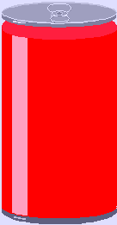
Figure 6. Spheroidality Strengthens Can's Load Bearing Capacity.
Perpendicular angle has been replaced with a curve.
Inventive Principle #35 is
Transformation of the physical and chemical states of an object
Change an object's aggregate state, density distribution, degree of flexibility, temperature
Example:
- In a system for brittle friable materials, the surface of the spiral feedscrew was made from an elastic material with two spiral springs. To control the process, the pitch of the screw could be changed remotely.
Change the composition to a stronger metal alloy used for the can wall to increase the load bearing capacity.
In less than one week, the inventor Jim Kowalik of Renaissance Leadership Institute was able to propose over twenty usable solutions to the U.S. canned beverage industry, several which have been adopted.

Table 3. The 40 Inventive Principles.
1. Segmentation
a. Divide an object into independent parts
b. Make an object sectional
c. Increase the degree of an object's segmentation
Examples:
- Sectional furniture, modular computer components, folding wooden ruler
- Garden hoses can be joined together to form any length needed
2. Extraction
a. Extract (remove or separate) a "disturbing" part or property from an object, or
b. Extract only the necessary part or property
Example:
- To frighten birds away from the airport, use a tape recorder to reproduce the sound known to excite birds. (The sound is thus separated from the birds.)
3. Local Quality
a. Transition from a homogeneous structure of an object or outside environment/action to a heterogeneous structure
b. Have different parts of the object carry out different functions
c. Place each part of the object under conditions most favorable for its operation
Examples:
- To combat dust in coal mines, a fine mist of water in a conical form is applied to working parts of the drilling and loading machinery. The smaller the droplets, the greater the effect in combating dust, but fine mist hinders the work. The solution is to develop a layer of coarse mist around the cone of fine mist.
- A pencil and eraser in one unit.
4. Asymmetry
a. Replace a symmetrical form with an asymmetrical form.
b. If an object is already asymmetrical, increase the degree of asymmetry
Examples:
- Make one side of a tire stronger than the other to withstand impact with the curb
- While discharging wet sand through a symmetrical funnel, the sand forms an arch above the opening, causing irregular flow. A funnel of asymmetrical shape eliminates the arching effect. [add picture here]
5. Combining
a. Combine in space homogeneous objects or objects destined for contiguous operations
b. Combine in time homogeneous or contiguous operations
Example:
- The working element of a rotary excavator has special steam nozzles to defrost and soften the frozen ground
6. Universality
Have the object perform multiple functions, thereby eliminating the need for some other object(s)
Examples:
- Sofa which converts into a bed
- Minivan seat which adjusts to accommodate seating, sleeping or carrying cargo
7. Nesting
a. Contain the object inside another which, in turn, is placed inside a third object
b. Pass an object through a cavity of another object
Examples:
- Telescoping antenna
- Chairs which stack on top of each other for storage
- Mechanical pencil with lead stored inside
8. Counterweight
a. Compensate for the object's weight by joining with another object that has a lifting force
b. Compensate for the weight of an object by interaction with an environment providing aerodynamic or hydrodynamic forces
Examples:
- Boat with hydrofoils
- A rear wing in racing cars which increases pressure from the car to the ground
9. Prior counter-action
a. Perform a counter-action in advance
b. If the object is (or will be) under tension, provide anti-tension in advance
Examples:
- Reinforced concrete column or floor
- Reinforced shaft made from several pipes which have been previously twisted to some specified angle
10. Prior action
a. Carry out all or part of the required action in advance
b. Arrange objects so they can go into action in a timely matter and from a convenient position
Examples:
- Utility knife blade made with a groove allowing the dull part of the blade to be broken off, restoring sharpness
- Rubber cement in a bottle is difficult to apply neatly and uniformly. Instead, it is formed into a tape so that the proper amount can be more easily applied.
11. Cushion in advance
Compensate for the relatively low reliability of an object by countermeasures taken in advance
Example:
- Merchandise is magnetized to deter shoplifting.
12. Equipotentiality
Change the working conditions so that an object need not be raised or lowered.
Example:
- Automobile engine oil is changed by workers in a pit to avoid using expensive lifting equipment
13. Inversion
a. Instead of an action dictated by the specifications of the problem, implement an opposite action
b. Make a moving part of the object or the outside environment immovable and the non-moving part movable
c. Turn the object upside-down
Example:
- Abrasively cleaning parts by vibrating the parts instead of the abrasive
14. Spheroidality
a. Replace linear parts or flat surfaces with curved ones; replace cubical shapes with spherical shapes
b. Use rollers, balls spirals
c. Replace a linear motion with rotating movement; utilize a centrifugal force
Example:
- Computer mouse utilized ball construction to transfer linear two-axis motion into vector motion
15. Dynamicity
a. Make an object or its environment automatically adjust for optimal performance at each stage of operation
b. Divide an object into elements which can change position relative to each other
c. If an object is immovable, make it movable or interchangeable
Examples:
- A flashlight with a flexible gooseneck between the body and the lamp head
- A transport vessel with a cylindrical-shaped body. To reduce the draft or a vessel under full load, the body is comprised of two hinged, half-cylindrical parts which can be opened.
16. Partial or overdone action
If it is difficult to obtain 100% of a desired effect, achieve somewhat more or less to greatly simplify the problem
Examples:
- A cylinder is painted by dipping into paint, but contains more paint than desired. Excess paint is then removed by rapidly rotating the cylinder.
- To obtain uniform discharge of a metallic powder from a bin, the hopper has a special internal funnel which is continually overfilled to provide nearly constant pressure.
17. Moving to a new dimension
a. Remove problems with moving an object in a line by two-dimensional movement (i.e. along a plane)
b. Use a multi-layered assembly of objects instead of a single layer
c. Incline the object or turn it on its side
Example:
- A greenhouse which has a concave reflector on the northern part of the house to improve illumination of that part of the house by reflecting sunlight during the day.
18. Mechanical vibration
a. Set an object into oscillation
b. If oscillation exists, increase its frequency, even as far as ultrasonic
c. Use the resonant frequency
d. Instead of mechanical vibrations, use piezovibrators
e. Use ultrasonic vibrations in conjunction with an electromagnetic field
Examples:
- To remove a cast from the body without injuring the skin, a conventional hand saw was replaced with a vibrating knife
- Vibrate a casting mold while it is being filled to improve flow and structural properties
19. Periodic action
a. Replace a continuous action with a periodic (pulsed) one
b. If an action is already periodic, change its frequency
c. Use pulsed between impulses to provide additional action
Examples:
- An impact wrench loosens corroded nuts using impulses rather than continuous force
- A warning lamp flashes so that it is even more noticeable than when continuously lit
20. Continuity of a useful action
a. Carry out an action continuously (i.e. without pauses), where all parts of an object operate at full capacity
b. Remove idle and intermediate motions
Example:
- A drill with cutting edges which permit cutting in forward and reverse directions
21. Rushing through
Perform harmful or hazardous operations at very high speed
Example:
- A cutter for thin-walled plastic tubes prevents tube deformation during cutting by running at a very high speed (i.e. cuts before the tube has a chance to deform)
22. Convert harm into benefit
a. Utilize harmful factors or environmental effects to obtain a positive effect
b. Remove a harmful factor by combining it with another harmful factor
c. Increase the amount of harmful action until it ceases to be harmful
Examples:
- Sand or gravel freezes solid when transported through cold climates. Over-freezing (using liquid nitrogen) makes the ice brittle, permitting pouring.
- When using high frequency current to heat metal, only the outer layer became hot. This negative effect was later used for surface heat-treating.
23. Feedback
a. Introduce feedback
b. If feedback already exists, reverse it
Examples:
- Water pressure from a well is maintained by sensing output pressure and turning on a pump if pressure is too low
- Ice and water are measured separately but must combine to total a specific weight. Because ice is difficult to dispense precisely, it is measured first. The weight is then fed to the water control device, which precisely dispenses the needed amount.
24. Mediator
a. Use an intermediary object to transfer or carry out an action
b. Temporarily connect an object to another one that is easy to remove
Example:
- To reduce energy loss when applying current to a liquid metal, cooled electrodes and intermediate liquid metal with a lower melting temperature are used.
25. Self-service
a. Make the object service itself and carry out supplementary and repair operations
b. Make use of wasted material and energy
Examples:
- To prevent wear in a feeder which distributes an abrasive material, its surface is made from the abrasive material
- In an electric welding gun, the rod is advanced by a special device. To simplify the system, the rod is advanced by a solenoid controlled by the welding current.
26. Copying
a. Use a simple and inexpensive copy instead of an object which is complex, expensive, fragile or inconvenient to operate.
b. Replace an object by its optical copy or image. A scale can be used to reduce or enlarge the image.
c. If visible optical copies are used, replace them with infrared or ultraviolet copies
Example:
- The height of tall objects can be determined by measuring their shadows.
27. Inexpensive, short-lived object for expensive, durable one
Replace an expensive object by a collection of inexpensive ones, forgoing properties (e.g. longevity)
Examples:
- Disposable diapers
28. Replacement of a mechanical system
a. Replace a mechanical system by an optical, acoustical or olfactory (odor) system
b. Use an electrical, magnetic or electromagnetic field for interaction with the object
c. Replace fields
1. Stationary fields with moving fields
2. Fixed fields with those which change in time
3. Random fields with structured fields
d. Use a field in conjunction with ferromagnetic particles
Example:
- To increase the bond between metal coating and a thermoplastic material, the process is carried out inside an electromagnetic field which applies force to the metal
29. Pneumatic or hydraulic construction
Replace solid parts of an object by gas or liquid. These parts can use air or water for inflation, or use air or hydrostatic cushions
Examples:
- To increase the draft of an industrial chimney, a spiral pipe with nozzles was installed. When air flows through the nozzles, it creates an air-like wall, reducing drag.
- For shipping fragile products, air bubble envelopes or foam-like materials are used.
30. Flexible membranes or thin film
a. Replace traditional constructions with those made from flexible membranes or thin film
b. Isolate an object from its environment using flexible membranes or thin film
Example:
- To prevent water evaporation from plant leaves, polyethylene spray was applied. After a while, the polyethylene hardened and plant growth improved, because polyethylene film passes oxygen better than water vapor.
31. Use of porous material
a. Make an object porous or add porous elements (inserts, covers, etc.)
b. If an object is already porous, fill the pores in advance with some substance
Example:
- To avoid pumping coolant to a machine, some of its parts are filled with a porous material soaked in coolant liquid. The coolant evaporates when the machine is working, providing short-term uniform cooling.
32. Changing the color
a. Change the color of an object or its surroundings
b. Change the degree of translucency of an object or processes which are difficult to see
c. Use colored additives to observe objects or processes which are difficult to see
d. If such additives are already used, employ luminescent traces or tracer elements
Examples:
- A transparent bandage enabling a wound to be inspected without removing the dressing
- A water curtain used to protect steel mill workers from overheating blocked infrared rays but not the bright light from the melted steel. A coloring was added to the water to create a filter effect while preserving the transparency of the water.
33. Homogeneity
Make those objects which interact with a primary object out of the same material or material that is close to it in behavior.
Example:
- The surface of a feeder for abrasive grain is made of the same material that runs through the feeder, allowing a continuous restoration of the surface.
34. Rejecting and regenerating parts
a. After it has completed its function or become useless, reject or modify (e.g. discard, dissolve, evaporate) an element of an object
b. Immediately restore any part of an object which is exhausted or depleted
Examples:
- Bullet casings are ejected after the gun fires
- Rocket boosters separate after serving their function
35. Transformation of the physical and chemical states of an object
Change an object's aggregate state, density distribution, degree of flexibility, temperature
Example:
- In a system for brittle friable materials, the surface of the spiral feedscrew was made from an elastic material with two spiral springs. To control the process, the pitch of the screw could be changed remotely.
36. Phase transformation
Implement an effect developed during the phase transition of a substance. For instance, during the change of volume, liberation or absorption of heat.
Example:
- To control the expansion of ribbed pipes, they are filled with water and cooled to a freezing temperature
37. Thermal expansion
a. Use a material which expands or contracts with heat
b. Use various materials with different coefficients of heat expansion
Example:
- To control the opening of roof windows in a greenhouse, bimetallic plates are connected to the windows. A change in temperature bends the plates, causing the window to open or close.
38. Use strong oxidizers
a. Replace normal air with enriched air
b. Replace enriched air with oxygen
c. Treat an object in air or in oxygen with ionizing radiation
d. Use ionized oxygen
Example:
- To obtain more heat from a torch, oxygen is fed to the torch instead of atmospheric air
39. Inert environment
a. Replace the normal environment with an inert one
b. Carry out the process in a vacuum
Example:
- To prevent cotton from catching fire in a warehouse, it is treated with inert gas while being transported to the storage area.
40. Composite materials
Replace a homogeneous material with a composite one
Example:
- Military aircraft wings are made of composites of plastics and carbon fibers for high strength and low weight

Table 4. Table of Contradictions.
(separate sheet)

4.0 Additional TRIZ Tools
The TRIZ methodology can be adapted to different kinds of problem solving. The method described above is relatively simple but forces the user to pre-formulate the problem in terms of standard engineering parameters. It rarely leads to an exhaustive set of solutions. Thus, it is used primarily to solve level two type problems as explained in Table 1. More difficult problems are solved with the following more precise tools.

4.1 ARIZ (Algorithm for Inventive Problem Solving)
A systematic procedure for identifying solutions without apparent contradictions. Depending on the nature of the problem, anywhere from five to sixty steps may be involved. From an unclear technical problem, the underlying technical problem can be revealed. Can be used with levels two, three, and four problems. Basic steps include
- Formulate the problem.
- Transform the problem into a model.
- Analyze the model.
- Resolve physical contradictions.
- Formulate ideal solution.

4.2 Su-Field Analysis
A tool for expressing function statements in terms of one object acting on another object. The objects are called substances and the action a field. Su-field analysis is helpful in identifying functional failures. By looking at actions as fields, undesirable or insufficient actions can be countered by applying opposing or an intensified fields.

4.3 Anticipatory Failure Determination (AFD)
Prevention of unanticipated failures is important in new product development. AFD, in effect, invents failure mechanisms and then examines the possibilities of their actually occurring. Factors contributing to the failures can be eliminated with this highly pro-active technique.

4.4 Directed Product Evolution (DPE)
Traditional technological forecasting tries to predict the "future characteristics of … machines, procedures, or techniques." It relies on surveys, simulations, and trends to create a probabilistic model of future developments. It gives a forecast, but does not invent the technology being forecasted.
Altshuller, by studying hundreds of thousands of patents, was able to determine eight patterns of how technological systems develop over time. Based upon the patterns of how people think rather than what people think, DPE is like a road map into the future. Rather than predicting future technologies, one can systematically invent future technologies using DPE. The eight patterns of Directed Product Evolution are given in Table 5. Examples will also be shown.
Table 5. Patterns of Evolution of Technological Systems.
 | Pattern | Example
1. | Technology follows a life cycle of birth, growth, maturity, decline. | Stage 1. A system does not yet exist, but important conditions for its emergence are being developed.  Stage 2. A new system appears due to high-level invention, but development is slow.  Stage 3. Society recognizes value of the new system.  Stage 4. Resources for original system concept end.  Stage 5. Next generation of system emerges to replace original system.  Stage 6. Some limited use of original system may coexist with new system. | 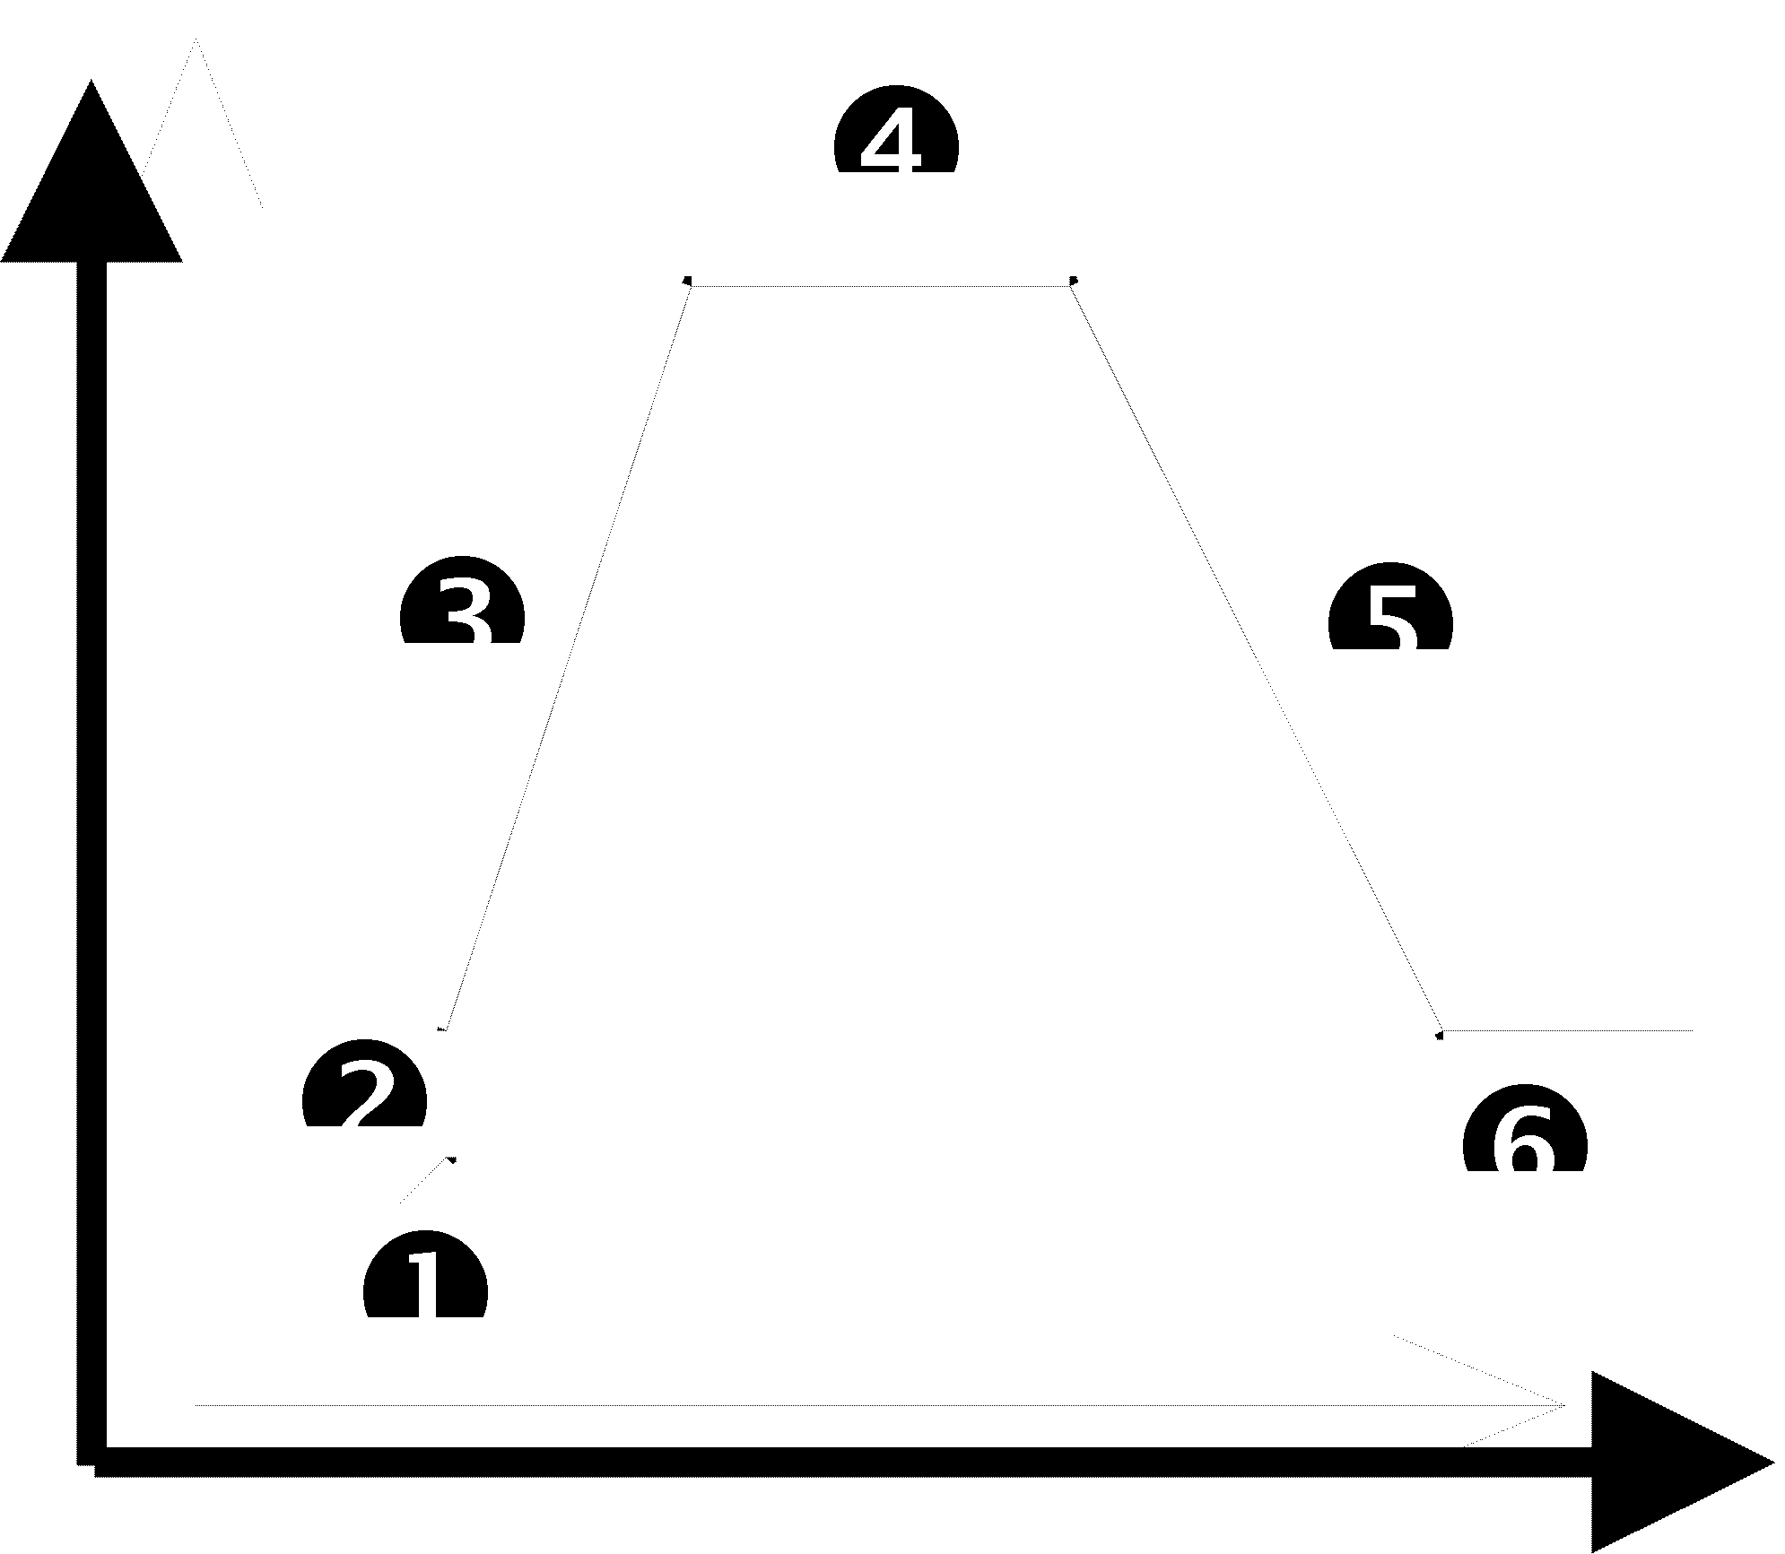  Case Study: Airplane  1. Manual attempts to fly fail.  2. Wright Brothers fly at 30mph in biplane.  3. Military use in WWI. Financial resources available. Speeds increase to 100mph.  4. Wood and rope frame aerodynamics reach limit.  5. Metal frame monoplane developed.  6. Several new types of airplanes have been developed but limited use of biplanes still exists.
2. | Increasing Ideality. | ENIAC computer in 1946 weighed several tons, took a whole room, and did computational functions. In 1995, Toshiba Portégé 610CT weighs 4.5 pounds and is capable of text processing, mathematical calculations, communications, graphics, video, sound.
3. | Uneven development of subsystems resulting in contradictions. | Subsystems have different life cycle curves. Primitive subsystems hold back development of total system. Common mistake is to focus on improving wrong subsystem. Poor aerodynamics were limitations of early planes but developers focused engine power instead of improving aerodynamics.
4. | Increasing dynamism and controllability. | Early automobiles were controlled by engine speed. Then manual gearbox, followed by automatic transmissions, and continuously variable transmissions (CVT.)
5. | Increasing complexity, followed by simplicity through integration. | Stereo music systems have evolved from adding separate components such as speakers, AM/FM radio, cassette player, CD player, etc. to integrated "boom box."
6. | Matching and mismatching of parts. | - Early automobiles used leaf springs to absorb vibration. These were an assembly of unrelated or mismatched parts borrowed from horse carriages and whatever else was available.  - Later fine tuning allowed adjustments of the parts so that they mated into a matched system - the shock absorber.  - Purposely mismatch parts to create additional resources from the differences. An example of this might be using a bimetal spring that changed spring rates when a current is applied.  - Automatic matching and mismatching as needed. For example a computer controlled active suspension system.
7. | Transition from macrosystems to microsystems using energy fields to achieve better performance or control. | Development of cooking systems from wood burning stove to gas ranges to electric ranges to microwave ovens.
8. | Decreasing human involvement with increasing automation. | Development of clothes washing from washboard to washing machine with ringer to automatic washing machine to automatic washing machine with automatic bleach and softener dispensers.
By analyzing the current technology level and contradictions in our products, TRIZ can be used to see the evolutionary progress and create the future. For example, Altshuller was able to predict the future technology of glass plate manufacturing. The earlier process was to roll hot glass onto a conveyor. During this process, the glass would tend sag between the rollers resulting in waviness in the final product. Using pattern #7, Transition from Macro to Micro, Altshuller predicted that rollers would get smaller and smaller until they reached the theoretical limit of atom sized. Several years later, an English company introduced a new process of rolling the glass out on a bath of liquid tin.
Directed Product Evolution can be used to develop patents for future technology before one's competitors.

5. TRIZ with QFD
Since TRIZ can help engineers and developers solve technical contradictions and invent new technologies, it's use in New Product Development is very important. Combined with
Quality Function Deployment (QFD), a company should be able to identify important customer requirements and then solve any technical bottlenecks that arise. TRIZ can also help identify new functions and performance levels to achieve truly exciting levels of quality. The following Table 6. shows areas where QFD and TRIZ can compliment each other. To learn more about QFD, please refer to the books in the reference section of this article.
Table 6. Using QFD and TRIZ Together.
Development Phase | QFD Deployment | Benefit of QFD and TRIZ Together
Market Research | 7 Product Planning Tools | Use Directed Product Evolution (DPE) with concept methods to show customers what new products will be like.
R&D | Technology Deployment | To solve engineering bottlenecks and contradictions.
 | Quality Deployment | To eliminate contradictions discovered by the roof of the House of Quality.
 |  | Help determine target values in the Quality Planning Table
Design | Function Deployment | Use Su-Field Analysis and DPE to identify new functions to excite customers.
 | Reliability Deployment | Use Anticipatory Failure Determination to identify and prevent catastrophic failure modes in new products.
 | Concept Deployment | Use TRIZ to develop new concepts by DPE patterns in Table 5.
 | Cost Deployment | Use TRIZ to lower costs without resorting to tradeoffs.
Manufacturing | Equipment Deployment | Remove design constraints due to limitations of equipment and manufacturability.
Production | Process Deployment | Remove design constraints due to limitations of processes and people.
After Service | Service Deployment | Help in design for serviceability. Remove service bottlenecks.

6.0 U.S. Companies Using TRIZ
Here is a list of some of the companies that have begun studying and using TRIZ in the U.S. since 1993.
Allied Signal Aerospace Sector
Chrysler Corp.
Emerson Electric
Ford Motor Co.
General Motors Corp.
Johnson & Johnson
Rockwell International
UNISYS
Xerox Corporation

7.0 TRIZ Software
Because TRIZ is built on a database of hundreds of thousands of patents, principles, operators, contradictions, etc. use of software helps engineers with minimal training achieve timely results. Here is a description of some of the software packages available.
Ideation International Inc. features two principle TRIZ scientists, Boris Zlotin and Alla Zusman, both students of the founder of the methodology, G.S. Altshuller. They reside in Detroit, Michigan the automotive capital of the world. With their staff, they have been advancing and adapting Altshuller's methods to the American style.
Their software team has developed a number of software packages to assist engineers in apply TRIZ to their products. Here is a brief description of the software.
Software Name | Purpose | Sample of Software Screen
Improver | Improve existing designs  Improve manufacturing process  Improve system performance Improve system quality  Improve manufacturing cost  Improve patent applications  Improve product features | 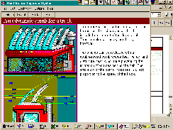
Ideator | ARIZ helps you to create abstract models of a system, including the formulation of contradictions and envisioning of the ideal situation.  Idealization is a process used to bring your system as close to ideal as possible.  Innovation Mini-Guide contains approximately 100 technical applications of physical, chemical and geometrical effects. | 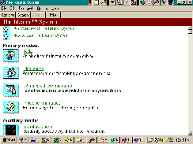
Eliminator (Appetizer) | The Ideation Appetizer is designed to help you find truly elegant and innovative problem solutions without any drawbacks or trade-offs. | 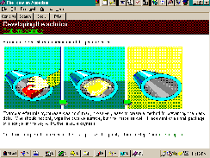
Innovation Workbench TM (IWB) |  | 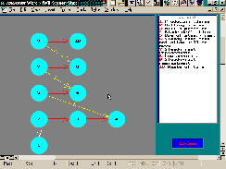

8.0 References
Altshuller, Henry. 1994. The Art of Inventing (And Suddenly the Inventor Appeared). Translated by Lev Shulyak. Worcester, MA: Technical Innovation Center. ISBN 0-9640740-1-X
Braham, James. "Inventive ideas grow with 'Triz.'" Machine Design. Vol. 67 No. 18. October 12, 1995.
Ideation International. "Assessment of Invention via Utilization of Ideation Methodology (the U.S. Adaptation of the Russian-developed TRIZ)." Ideation International, Inc. Santa Monica, CA. Fax: +1 (810) 353-5495.
Ideation International. "Directed Product Evolution." Ideation International, Inc. Santa Monica, CA. Fax: +1 (810) 353-5495.
Ideation International. 1995. Ideation Methodology v.4.0 Ideation International, Inc. Santa Monica, CA. Fax: +1 (810) 353-5495.
Ideation International. "The Process for Systematic Innovation." Ideation International, Inc. Santa Monica, CA. Fax: +1 (810) 353-5495.
Ideation International. "TRIZ History and Background." Ideation International, Inc. Santa Monica, CA. Fax: +1 (810) 353-5495.
Ideation International. "TRIZ/Ideation Methodology Tools for Systematic Innovation." Ideation International, Inc. Santa Monica, CA. Fax: +1 (810) 353-5495.
Kaplan, Stan. "An Introduction to TRIZ: The Russian Theory of Inventive Problem Solving." Draft. Ideation International, Inc. Santa Monica, CA. Fax: +1 (810) 353-5495.
Verduyn, David M. and Alan Wu. 1995. Integration of QFD, TRIZ, & Robust Design: Overview & "Mountain Bike" Case Study. ASI Total Product Development Symposium, Nov. 1-3, 1995, Dearborn, MI.

9.0 Ideation Triz Team

Boris Zlotin
Over 20 years experience in TRIZ and engineering. Co-author of 9 books on TRIZ, including 3 with G. Altshuller, TRIZ founder. Teaching TRIZ experience over 8,000 hours. Over 6,000 hours of TRIZ consultations. Facilitated solving over 4,000 technological and business problems. Taught TRIZ to over 5,000 students. Advanced the methodology including Patterns of Evolution in different areas, US adaptation of the methodology, developing new applications such as solving scientific and business problems. Developed the theoretical base for TRIZ software products.

Alla Zusman
Over 15 years experience in TRIZ. Co-author of 7 books on TRIZ, including one with G. Altshuller, TRIZ founder. Teaching TRIZ experience over 3,000 hours. Taught TRIZ to over 3,000 students, including over 300 in US. Advanced the methodology including US adaptation of the methodology, developing new applications such as solving scientific and business problems. Developed the theoretical base for TRIZ software products.

Sergey Malkin
Over 10 years of TRIZ experience as a TRIZ teacher and problem solver. Primary architect of Ideation TRIZ-based software products.

Gafur Zainiev, Ph.D.
Over 20 years of experience in the design and development of micromethods in the field of molecular cell biology. Developed and taught a new course for University students entitled TRIZ-based Introduction to the Study of Biology.

Len Kaplan
Over 15 years of TRIZ experience teaching and developing TRIZ, solving inventive problems using the methodology, and developing TRIZ-based software products. Named inventor on eleven patents.

The information on this Web Site has been substantially provided by and used with the permission of Ideation International Inc. For more information about Ideation International, contact Mr. Zion Bar-El at Ideation International Inc., 23713 Riverside Drive, Southfield MI 48034 USA. Telephone: +1 313-353-1313. Facsimile: +1 313-353-5495. E Mail: zionb@aol.com or click here.

This page was created for viewing with Netscape v2.0. Download the latest version of Netscape by clicking here. Some Netscape features may not be supported by your Web Browser. Should strange appearances occur, email me regarding the misbehaving area along with the name and version of the browser you are using.
Copyright © 1995 by Glenn Mazur . All rights reserved. In the spirit of TQM, this page is continuously improved. Suggestions can be emailed to mailto:gmazur@engin.umich.edu or by clicking here. Last update: February 26, 1996.
To learn more about QFD, visit my virtual QFD course pack at the University of Michigan College of Engineering at http://www.mazur.net/tqm/tqm8.htm or by clicking here. For more information about TQM, click here.
This page created by Glenn Mazur.

