Mansiyon ''iFACE''

Göktuğ F. GÖKDOĞAN
Bilkent Ünv. – Elektrik Elektronik Müh. Y. Lisans Öğrencisi
gokdogan@cs.bilkent.edu.tr

Onur ÖNDER
Bilkent Ünv. – Elektrik Elektronik Müh. Y. Lisans Öğrencisi
oonder@cs.bilkent.edu.tr

Proje Adı: iFACE

İnsan-bilgisayar etkileşimi bilgi biliminin gelişen alanında önemli bir konudur. Bilgisayarlar insanlar gibi gerçek hayat verilerini yakalamak ve yorumlamakla kalmayıp gerçek hayatı taklit de edebilmektedirler. Şu anda bir giriş aygıtı yardımı ile bir insanın yüzünü yakalayabilmek, bazı yüzsel ifadeleri analiz etmek ve bunları kas tabanlı deformasyon fonksiyonu ile bir 3D model mümkündür. Böylece bir bilgisayar için insan ifadelerini suni olarak yinelemek mümkün olmaktadır. Projenin ayrıntılı tanıtımı aşağıda ingilizce olarak verilmiştir.

Introduction

In the growing field of technology and science, computers are becoming more powerful in terms of analyzing and simulating real life data. The simulation of the real life in the computers enables humans to understand the nature of our lives. This may enable human being to create and develop new techniques and tools to increase the life quality. It may also enable us to predict the future up to a certain point.
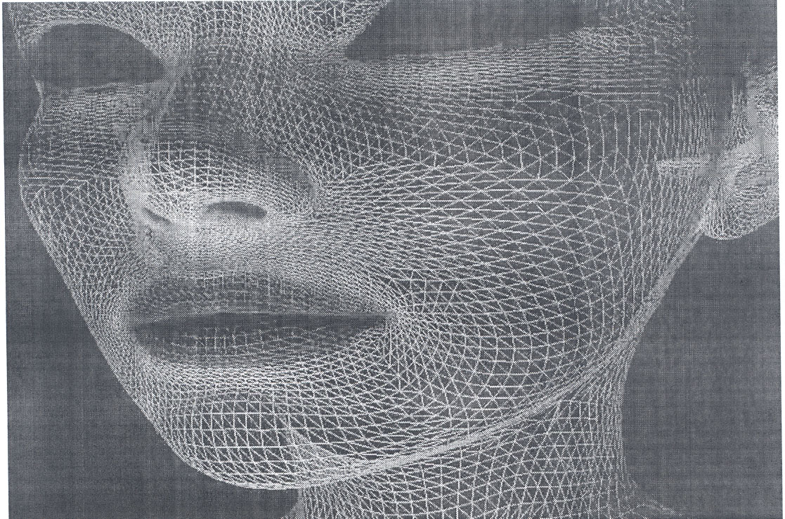
In terms of controlling the simulation world of computers, human computer interaction plays a great role, how will computers understand and get data from users, how will they interpret and present the results to its users? There are many techniques for these operations, there are many input devices for computers, but the most natural one would be that the computers would understand humans by capturing the real world data from them, such as the informal languages we talk, or the body languages we use.
In this project, we aim to capture human facial expressions with a computer, and simulate these expressions in a virtual 3D model. Capturing facial expressions includes the movements of some certain key points in the face, and letting these points to be mapped to a 3D model. By this way, we can capture a face from a digital camera and apply the changes in the face to the model, which can be any model such as a face of another human, or alien, a dog or a cat.
The project would require the designers and implementers to think and act from the computer’s point of view, to be able to capture the data from the computer’s vision and project it onto a model, which is also totally defined in a virtual environment.
This project may initiate a new age in the human computer interaction, such as understanding the humans or commands by just capturing their pose, expressions; and outputting with the help of an entity (such as a face) as if the computer also has a face, where you can interact with.

